# Recommendation 6: Improving safety in isolated environments

Recommendation 6 requires Ambulance Victoria to address safety risks posed to staff working in isolated environments through an audit.

The original recommendation was for Ambulance Victoria to audit all isolated work environments. In April 2022, Ambulance Victoria contacted the Commission about its approach to this recommendation. The Commission advised that Ambulance Victoria could consider an approach where a representative sample of sites were audited to identify common issues and necessary security measures to be implemented across the organisation. Findings could then be applied in non-audited sites in accordance with the guidance and criteria identified by the auditor.

## Recommendation intent and why it matters

Being able to come to work without fearing for your physical or psychological safety is an ethical and legislated right. Protecting safety in isolated environments is necessary in order for Ambulance Victoria to comply with its obligations under the *Equal Opportunity Act 2010* (Vic)[1] and the *Occupational Health and Safety Act 2006* (Vic)and is critical to Ambulance Victoria creating and maintaining a safe, equal and inclusive place to work or volunteer. People who feel safe and valued are better able to focus and do a good job.

The Commission considers it reasonable and proportionate for an organisation of Ambulance Victoria’s size to take steps to identify and mitigate the risks posed by isolated environments.

The Commission made this recommendation to ensure work environments that pose greater safety risks are audited and any necessary measures to mitigate these risks are implemented.

## Findings

### What we found in Phase 1 of the Review

Isolated work environments were one of 3 key work-related risk factors[2] identified during Phase 1 of the Review that contribute to the risks of bullying and sexual harassment occurring. See section 6.1.6 of the [Phase 1 Report](https://www.humanrights.vic.gov.au/static/5631441a7f206c4abe904a040db49254/Resource-Ambulance_Victoria_Independent_Review_Workplace_Equality-Volume_2-Final-Report_v2.pdf). Isolation can stem from the physical structure of buildings, job requirements or geographical factors. Unsociable working hours, long work periods in confined spaces and social isolation can heighten these risks.

Work on ambulance vehicles is particularly isolated and unsupervised, leading to instances of sexual harassment and bullying away from potential bystanders. Social isolation is also an issue for those who work in regional areas away from family and social networks. Sleeping quarters at branches further contribute to isolation and vulnerability, with some participants reporting serious sexual harassment in these spaces. Inadequate security, such as the inability to lock bedrooms or bathrooms, exacerbates this issue.

These factors not only increase the risk of unlawful conduct linked to age and gender (see Reform Barrier: Archetypes – Diversity and Inclusion), but also create barriers for victim-survivors to speak out due to the absence of witnesses and fear of disbelief.

[After he sexually assaulted me in the branch bedroom, I was afraid of being alone with him]. There was one other time where it was just him and I at branch. I was the single officer and I was restocking the truck. I was just in the storeroom … you can’t get out of there. It’s just one entrance.

Phase 1 Participant

### What we found in Phase 3 of the Review

**Findings on the program of work**

**Ambulance Victoria had engaged a consultant to undertake a security audit of a representative sample of its isolated work environments, resulting in a security audit report with 34 recommendations**

In 2023, Ambulance Victoria engaged a consultancy firm with relevant experience and expertise to undertake a security audit of a representative sample of 63 of the organisation’s 273 operational branches and 7 of 29 corporate buildings. The audit examined the physical security of the sample of Ambulance Victoria buildings. The consultancy firm report noted that Victoria Police, Fire Rescue Victoria, WorkSafe Victoria and the National Disability Insurance Agency had been consulted as part of the audit. The consultant delivered its final report in August 2023.

The Commission heard from workforce survey participants that the types of safety issues originally proposed to be considered in the safety audit were reduced significantly (for example, fatigue, psychological safety, impacts of often working alone). The Commission notes that the consultant report stated its approach had been to ‘examine the physical security of the AV buildings’ and that there was no assessment of the mobile nature of operational work. The Commission is unaware of any work separate to the audit that assessed the safety risks associated with this way of working.

The following extract from the security audit report identifies 5 key risks and associated root causes under the themes of people, process and infrastructure.

The security audit report made 34 recommendations and of these recommendations Ambulance Victoria reported that it has:

* accepted 8 in full
* accepted 15 in principle
* accepted 6 in principle with further investigation required
* not accepted 4 (on the basis that they were of low value and/or impact for the workforce or will be fulfilled by other accepted/accepted in principle audit recommendations)
* considered that one was already implemented.

Extract of security audit report listing key risks identified by the consultant

|  |  |  |
| --- | --- | --- |
| Theme | Risk | Root cause |
| People | Absence of security awareness is a contributor to the risk of both internal and external security | A lack of focus on security awareness from top management to help staff understand potential threats while at an AV site (Branch or Residence) |
| Without adequate leadership and processes to deal with and manage known internal threats across sites, staff’s sentiment of safety and security at AV will continue to be impacted | As outlined in the VEOHRC report, this is due to insufficient leadership, accountability, consequence  management and processes to address safety concerns of staff |
| Process | Inadequate resourcing introduces the risk that necessary maintenance activities will not be undertaken in a timely manner or completed adequately exposing staff to security threats due to poor workmanship | Maintenance activity is driven by reactive maintenance rather than preventive/proactive maintenance based on the asset lifecycle. In addition, there are inadequate systems in place to support effective work order management for maintenance |
| Inadequate, slow or no response to installed security alarms exposes staff to the potential for greater harm than necessary.  Insufficient visibility of the security threats which exist across the AV sites, which may limit AV’s ability to provide sufficient duty of care to its staff | Historically, AV has taken a reactive investigative approach to the use of  security monitoring at branches |
| Infrastructure | Insufficient capital investment to address physical security controls will increase the likelihood and consequence of both internal and external threats across AV | Inadequate capital funding and insufficient lead times for the acquisition and construction  of suitable modern facilities for medical first response in growing communities |

**Ambulance Victoria had developed a Roadmap to implement 23 recommendations from the security audit report, but not delivered its 2024 Roadmap activities**

The Roadmap outlines a plan to implement the ‘accepted and ‘accepted in principle’ recommendations across financial years (FY) starting in FY24 through to FY28.

The Commission did not find evidence that the 7 recommendations listed for delivery by FY24 had been completed or even commenced. All 7 of these recommendations were noted as being funded by business as usual.

Ambulance Victoria reported it had prioritised expanding the scope of existing branch audits in line with recommendations from the security audit and will conduct branch audits annually. The Commission did not otherwise receive evidence from Ambulance Victoria to demonstrate how the consultant’s audit findings and recommendations have been used to improve the safety of isolated environments generally and also to prevent unlawful workplace conduct pursuant to the *Equal Opportunity Act 2010* (Vic).

The Commission found that 9 of the recommendations ‘accepted in full’ or ‘accepted in principle’ required additional funding. A further 5 of these recommendations were listed as ‘to be confirmed’.

**In 2022 Ambulance Victoria had installed privacy locks in bathrooms and other private settings (for example, bedrooms) across all metropolitan and regional locations**

The Commission heard that this program of work has been seen as a positive step by the workforce. However, when surveyed about this work, of the 774 respondents in non-corporate roles only 518 (67%) said that there were working locks in sleeping areas at their main work location and questions were raised as to how effective the type of locks installed actually were in preventing harm.[3]

‘So the audit appeared to only involve structures, so the buildings, and we've had privacy locks put on the bathrooms and in the bedrooms, but they're more of a psychological barrier to any sort of intrusion because they're like the bathroom locks on a toilet door.’

Participant

**Ambulance Victoria did not have a program of work to systematically address safety in isolated environments across the organisation**

Ambulance Victoria provided the Commission with evidence that it monitors safety issues (for example, through a hazard and incident management system, maintenance requests, psychosocial surveys). At the time of the Progress Evaluation Audit, based on the evidence provided by Ambulance Victoria it appears that the program of privacy lock installation is the only major and organisation-wide piece of work underway to address safety in isolated environments.

**Findings on the early impacts of implementation of this recommendation**

**There was low awareness of the safety audit among the workforce**

The survey found only 25% of respondents were aware of the safety audit. Members of the workforce who were aware of the audit told the Commission they were not aware of any of the audit outcomes, nor what steps were planned by Ambulance Victoria to address any of the audit findings.

**There were low levels of workforce satisfaction with Ambulance Victoria’s work to improve safety in isolated environments since Phase 1 of the Review**

The survey found only 28% of survey respondents said they were satisfied with the steps Ambulance Victoria has taken to improve safety in isolated environments.

Survey respondents with disabilities and First Peoples (n=18) reported even lower satisfaction with safety measures taken to date compared to the broader workforce – 13% and 11% respectively. The Commission concludes from this that these 2 cohorts may have lower confidence in measures taken to improve safety.

Non-operational staff and first responders (n=22) rated their satisfaction with the steps Ambulance Victoria has taken on safety higher than the broader workforce – 46% and 50% respectively.

**There were very low levels of workforce confidence that Ambulance Victoria would implement the necessary steps to protect staff from harmful and unlawful conduct in isolated environments**

Only 16% of survey respondents said that they were confident that Ambulance Victoria would take the required steps to protect workers from harmful conduct in isolated environments.

Confidence was lower among Ambulance Paramedic 12s, Advanced Life Support (ALS) paramedics and Mobile Intensive Care Ambulance (MICA) paramedic interns. When looking at responses by work location, respondents in Barwon South West and Hume had lower confidence than the broader workforce at 9% and 8% respectively. Feelings of ‘not being confident at all’ that Ambulance Victoria would protect staff from harmful and unlawful conduct in isolated environments were highest in people with disabilities (50%) and First Peoples (72%).

**The workforce and unions had consistently raised with the Commission a range of safety concerns that they felt Ambulance Victoria was not properly addressing**

Examples of concerns raised with the Commission include (but are not limited to):

* women being offered roles or placements in isolated rural branches with no proactive sexual harassment risk identification and mitigation; this was an issue of concern identified in the Phase 1 Report – no systemic changes to practice have occurred and Ambulance Victoria remains non-compliant with its positive duty
* ineffective communication and monitoring systems and processes (for example, faulty radios, no proactive CCTV monitoring, regional areas not advised of the 2023 Optus outage, criticism of staff for activating duress alarms or duress alarms not working in regional areas due to issues with signal strength and radio network coverage)
* sole officers being sent to potentially unsafe callouts without backup and ineffective systems for identifying and flagging for responding paramedics patients with a known history of violence.

When the Commission raised these issues with senior leaders, it was clear from responses that there remains an imbalance in the priority given to operational KPIs versus prevention and wellbeing – a driver of harm identified in Phase 1.

**Many Ambulance Victoria staff reported feeling physically and psychologically unsafe at work**

Broad safety concerns were reflected in the 2024 workforce survey where:

* only 53% of respondents said they felt physically safe at Ambulance Victoria[4]
* only 15% of respondents said they felt psychologically safe at Ambulance Victoria;[5] 32% reported not feeling psychologically safe at all
* 51% of respondents said that expressing opinions was a barrier to career advancement at Ambulance Victoria, the second-highest ranked barrier after being on a Flexible Work Arrangement.

Cohorts who reported lower feelings of physical safety included LGBTIQA+ people, people with disabilities, First Peoples, ALS paramedics and people younger than 39.

Cohorts who reported lower feelings of psychological safety included people with disabilities, First Peoples, ALS paramedics, MICA/MICA flight paramedics and non-emergency patient transport staff.

‘There is not enough focus on psychological safety, especially in isolated environments, and I've supported some staff members to advocate for their wellbeing and support, which has been a disproportionate amount of effort compared to what they are seeking. It seems in these cases it's more about "a policy option doesn't exist to support them" than actually listening to the individual asking for help.’

Participant

The workforce survey asked participants to describe in their own words what contributed to their feelings of not being physically or psychologically safe. These responses were then coded into related groups by the Commission’s survey provider. The following graphs describe the response groups and the percentages of responses in each group. The Commission notes that in these responses the workforce has raised several safety concerns that include, but are not limited to, isolated work environments. The Commission also heard of these concerns consistently during interviews and focus groups.

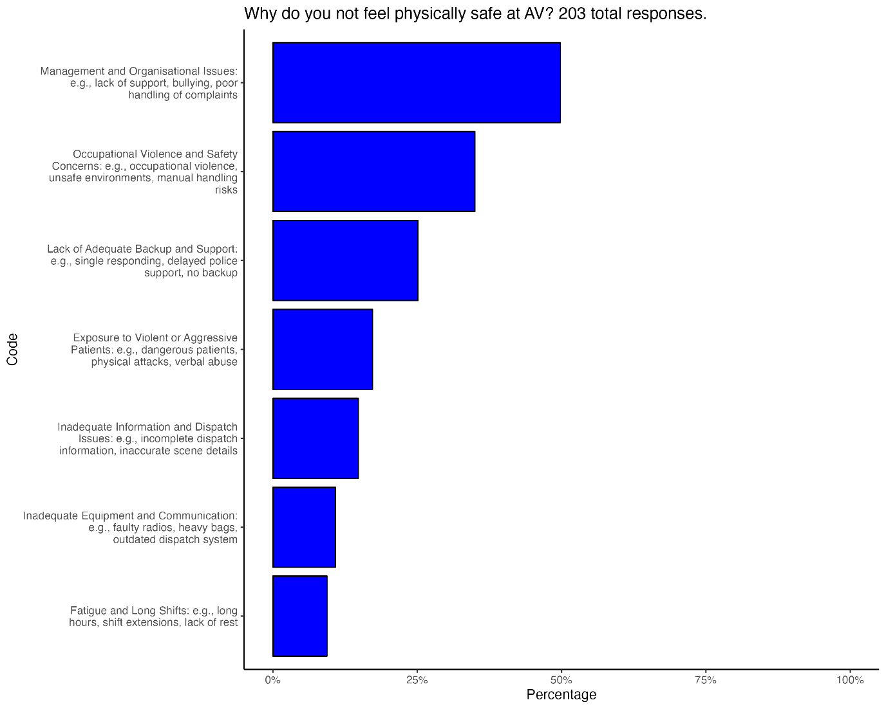

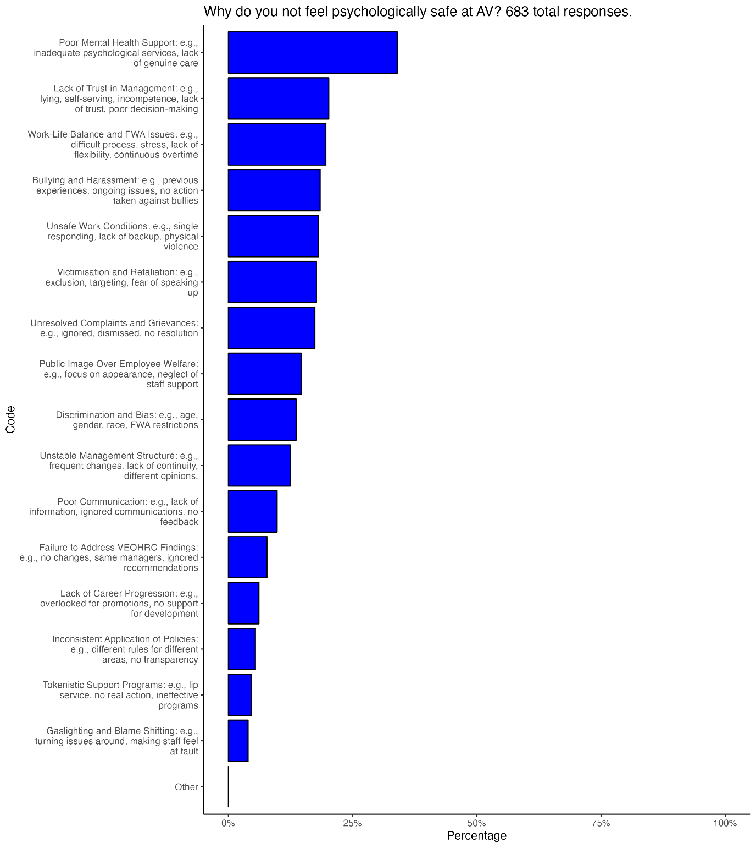

### Progress in achieving change

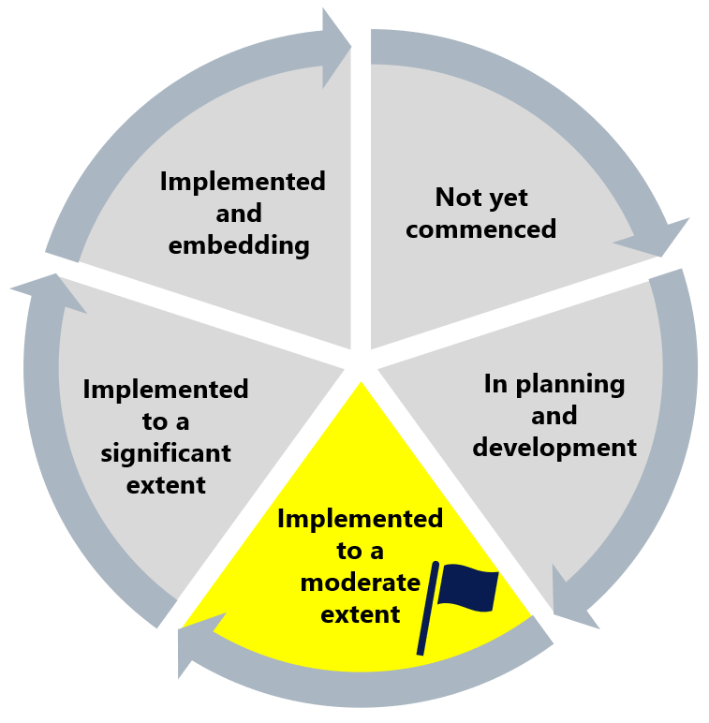

The Commission has assessed this recommendation as implemented to a moderate extent. While the safety audit has been completed, a significant amount of work remains for Ambulance Victoria to meet its legislative duty to identify and mitigate the risks posed by isolated environments and, more broadly, to create and maintain safe, equal and inclusive places to work or volunteer.

The Commission considers that the scope of the safety audit being limited to physical safety at branches and not including the mobile work environment is a missed opportunity.

While the Commission notes that Ambulance Victoria has some mechanisms to monitor workplace safety, there remains an urgent need for proactive and systemic approaches to improving safety in isolated environments in order to be compliant with the positive duty.

During the Progress Evaluation Audit, the Commission found evidence that safety issues at Ambulance Victoria are broader than just working in isolated environments and that these concerns (such as within the mobile working environment) are not being adequately addressed by Ambulance Victoria.

## What measures are still needed?

Ambulance Victoria's workforce conveyed to the Commission that many reform initiatives often seem like mere ‘tick the box’ exercises. This sentiment was particularly strong regarding the efforts related to the safety audit under Recommendation 6. To effectively address this reform barrier in this context, safety reforms should be tailored to the specific needs of the workforce, to ensure that initiatives are perceived as genuine efforts rather than mere 'tick the box' exercises. See Reform Barrier: Change Management Approach.

Harnessing workforce commitment is crucial in enhancing safety in isolated environments. By actively engaging and empowering employees, Ambulance Victoria can foster a culture of shared responsibility (see Reform Enabler: Workforce Commitment). This collective dedication should be combined with a more holistic and systemic approach to safety. This would contribute to Ambulance Victoria’s compliance with its workplace safety positive duty obligations. See Recommendation 3: A holistic evidence-based prevention plan.

Promoting a culture of prevention should also be recognised as a key enabler to improving psychological and physical safety at Ambulance Victoria. This may be achieved by embracing curiosity and transparency about safety, and acknowledging missteps with humility. These actions, among others, reduce attitudinal barriers to reform and actively promote a culture where upholding safety – both psychological and physical – is normalised. See Reform Enabler: Culture of Prevention.

A psychologically safe environment enables all members of the workforce to perform their roles effectively by fostering open communication and promoting trust. In such an environment, people feel confident to express ideas, admit mistakes and address challenges without fear of reprisal, leading to more collaborative and adaptive teams. Achieving this climate of trust, safety and support enhances leadership effectiveness and drives independence and autonomy among leaders. See Reform Enabler: Distributed Leadership.

1. Since Phase 1 of the Review, a new positive duty has been inserted into the *Sex Discrimination Act 1984* (Cth). It imposes a legal obligation on organisations and businesses to take proactive and meaningful action to prevent relevant unlawful conduct from occurring in the workplace or in connection to work.
2. Victorian Equal Opportunity and Human Rights Commission, Independent Review into Workplace Equality in Ambulance Victoria: Phase 1 (Volume I, 2021) 320.
3. Note: this data excluded the following roles on the basis that they may not have sleeping areas in their main work location: corporate, operational support and managerial employees, other.
4. This is similar to the result from the 2023 Ambulance Victoria People Matter Survey, where 58% of respondents agreed with the statement ‘my organisation provides a physically safe work environment’.
5. Similarly, across the 2021, 2022 and 2023 Ambulance Victoria People Matter Survey, results for organisational safety climate, including psychological safety, declined across all measures <https://vpsc.vic.gov.au/wp-content/uploads/2024/05/Ambulance-Victoria-Organisation-results-2023.pdf>.