# Recommendation 7: Resetting and embedding organisational values

Recommendation 7 requires Ambulance Victoria to adopt a new set of organisational values to guide behaviour. The values are to be co-designed with representatives of the organisation’s workforce, with input from key partners including the relevant unions and professional associations, the Department of Health and service users. It requires a communication plan and for the values to be shared throughout the organisation and implemented with strategies that ensure accountability for demonstrating values-driven behaviour.

## Recommendation intent and why it matters

Entrenching organisational values will bolster the implementation of recommendations from Phase 1 of the Review and ensure that the people who work or volunteer for Ambulance Victoria – those who give their time to care for others – are respected and treated with fairness and dignity.

Organisations that treat members of their workforce in this way become known as employers of choice, which helps them to attract and retain diverse and talented staff.

## Findings

### What we found in Phase 1 of the Review

The Commission’s Phase 1 Report[1] showed that Ambulance Victoria did not have meaningful and accountable values that clearly articulated what conduct is and is not tolerated. This was reflected in the high prevalence of multiple forms of inappropriate and unlawful conduct, including discrimination and sexual harassment. See section 6.2.3 of the Phase 1 Report.

### What we found in Phase 3 of the Review

**Ambulance Victoria had designed and adopted new organisational values**

Ambulance Victoria engaged Deloitte to redesign its organisational values through a co-design process, which was undertaken in early 2023.

The new organisational values along with a 3-year implementation plan were approved by Ambulance Victoria’s Board in April 2023. The values have been added to Ambulance Victoria’s Strategic Plan and created in visual and digital collateral.

**Ambulance Victoria’s new organisational values were co-designed with internal and external stakeholders**

Documents provided to the Commission by Ambulance Victoria demonstrate a 2-round co-design process which involved various stakeholders such as the workforce, Board, Executive and Staff Reference Group who were engaged through online surveys, focus groups, virtual sessions, stakeholder interviews and hospital visits. Over 2,350 members of the Ambulance Victoria workforce across more than 32 locations participated in the process. External stakeholders such as the Department of Health, relevant unions and professional associations were also consulted.

Through this engagement, Deloitte gathered key insights and themes, which informed the creation of proposed values aligned with the organisation's vision and principles. These values were further refined based on additional stakeholder feedback.

During the Progress Evaluation Audit, the Commission heard from members of the Ambulance Victoria workforce that they valued the co-design process. Co-design is recognised as an inclusive facilitation tool that creates favourable conditions for effective change management.[2] See Reform Barrier: Change Management Approach.

**The launch of Ambulance Victoria’s new organisational values appears to have derailed their implementation**

The new organisational values were launched at an offsite leadership meeting, which members of the workforce reported as having had an adverse impact on workforce sentiment around the new values, which the Commission has found is impacting adoption and implementation of the values. The Commission heard of the impact on morale for some staff who were disappointed that the AV service awards were cancelled due to budgetary constraints around the same time as the launch of the values.

*It was a really missed opportunity to engage the workforce and launch it properly. I think we failed that and we didn’t do it well. We've actually lost the workforce and the values have now become a negative aspect of what our workforce aligns themselves to.*

*Participant*

Promoting and embedding organisational values necessitate parallel efforts to actively engage the entire workforce, ensuring that reforms are supported and sustained through the commitment and involvement of all staff. See Reform Enabler: Workforce Commitment.

**There were varied views on the impact of the new organisational values among Ambulance Victoria’s leadership and workforce**

In discussions with leadership and the wider workforce, the Commission found senior leadership felt the new values had made an impact as they had ‘seen the values’ in practice as they visited and observed operational teams around the state. However, much of the operational workforce told the Commission they felt the values project was a wasted use of funding.

Responses in the workforce survey showed largely negative views on accountability for the new values:

* Only 13% felt that Ambulance Victoria as an organisation always or very often operates in line with the new values.
* Similarly, only 10% felt that senior leaders are always or very often held accountable for behaviour that is not in line with the new values. Sentiment was more positive for respondents’ direct managers, but the proportion of respondents reporting that they were always/very often held accountable was still only 41%.

The Commission found some evidence that the values are beginning to be included in some performance development plans (PDPs) and Ambulance Victoria has indicated that values will be included in all PDPs from 2025.

### Progress in achieving change

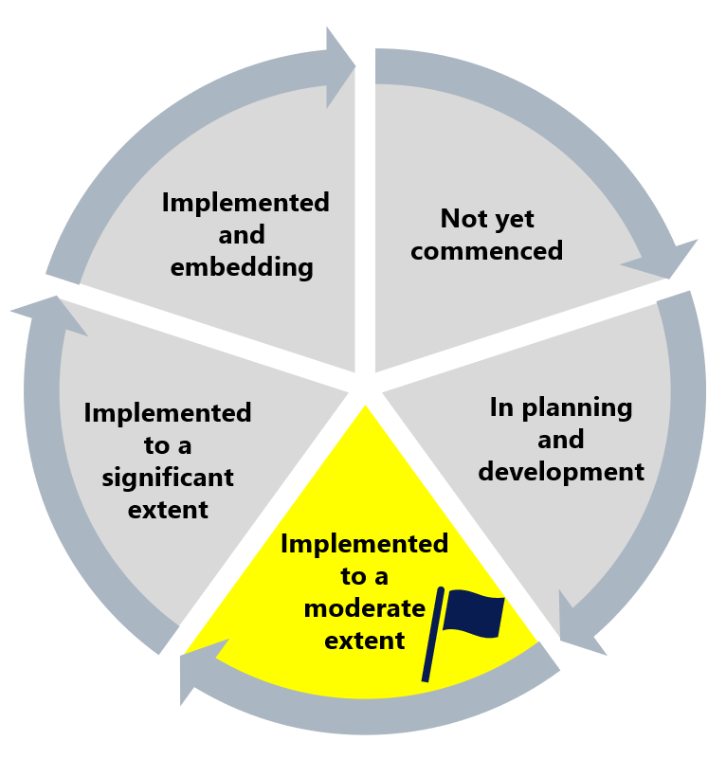

The Commission has found this recommendation has been implemented to a moderate extent. This acknowledges the work undertaken to develop and launch the new values, but recognises that Ambulance Victoria needs to undertake further work to embed the values across the organisation. The Commission has flagged this recommendation as requiring reconsideration of the implementation approach taken so far, in light of staff sentiment about the new organisational values following the difficulties around the launch of the organisational values at an offsite leadership meeting.

## What measures are still needed?

Building on the successful co-design process used to develop the new organisational values, the Commission encourages Ambulance Victoria to continue to engage the workforce in values implementation. The Commission considers that Ambulance Victoria should prioritise incorporating the new organisational values into KPIs and PDPs to ensure accountability for demonstrating values-driven behaviour.

The Commission considers that work to implement the new organisational values could be supported by promoting efforts to harness distributed leadership. A workplace where leaders consistently model the organisation’s values and are held accountable for behaviour that is unacceptable will be a key enabler of Recommendation 7. See Reform Enabler: Culture of Prevention.

Regionally dispersed leaders play a crucial role in modelling and monitoring workplace behaviour that aligns with the values, and they should be recognised as vital in embedding the new organisational values and be encouraged to highlight the values in regular, localised events and communications. See Reform Enabler: Harnessing Distributed Leadership.

Enhancing communication about the new values, and ways in which they can be demonstrated, will help to integrate the new values into the daily lives of the workforce, making them a living part of Ambulance Victoria’s culture. See Reform Enabler: Enhancing Communication.

1. Victorian Equal Opportunity and Human Rights Commission, Independent Review into Workplace Equality in Ambulance Victoria: Phase 1 (Volume I, 2021) 338.
2. Anna Salmi and Tuuli Mattelmäki, ‘From within and in-between – co-designing organizational change’ (2019) *CoDesign* 17(1) 101 <https://doi.org/10.1080/15710882.2019.1581817>.