# Recommendation 9: Contact officers and local champions network

Recommendation 9 requires Ambulance Victoria to reintroduce workplace equality contact officers in each region and implement a champions of change model to drive reforms for a safe and equal workplace culture.

## Recommendation intent and why it matters

As part of a holistic approach to prevention of harmful and unlawful conduct, a network of contact officers and local champions will support a culture of workplace safety and equality. It will also help Ambulance Victoria to meet its duties under the *Equal Opportunity Act 2010* (Vic)to prevent, identify and respond to unlawful workplace conduct.

Contact officers can:

* reduce barriers to speaking up and coming forward
* strengthen and diversify organisational expertise related to discrimination, sexual harassment, bullying, victimisation and workplace inequality
* support the identification of new and emerging risks of unlawful and harmful conduct within the organisation by opening a further (de-identified) source of information
* strengthen early-intervention measures and efforts to prevent harm before it occurs.

Champions can:

* support the implementation of the reforms at all levels (including local levels)
* build organisational capability by appointing informal leaders responsible for championing and advocating for the reforms and workplace equality
* help to identify new and emerging risks, particularly those arising from change implementation (including backlash).

## Findings

### What we found in Phase 1 of the Review

The Commission found that Ambulance Victoria’s approach to prevention was not working effectively and it was not meeting several *Equal Opportunity Act 2010* (Vic) obligations. During Phase 1 of the Review, Ambulance Victoria had 6 contact officers; however, the program was inactive and under review.

The Commission found that the absence of contact officers may have meant members of the workforce, who may have preferred to seek initial information and guidance from a peer, were less willing to raise concerns. The absence of contact officers also meant that Ambulance Victoria was missing further opportunities to learn (in a de-identified way) about the workforce’s experiences of discrimination, sexual harassment, bullying and victimisation, and to intervene to prevent this conduct.

The Commission found that the workforce had a fear of speaking up and that there was a culture of silence within Ambulance Victoria.

You either keep your mouth shut, do your job and fly under the radar. If you speak up, you get reprimanded and denied career progression.

Phase 1 Participant

Further information can be found on pages 109 and 290 of Volume I.

### What we found in Phase 3 of the Review

**Contact officers**

**Ambulance Victoria is undertaking a pilot Equality Contact Officer (ECO) program**

The Commission found that as part of the pilot, 4 people had been recruited and completed external ECO training in late May 2024 and further training was planned for June 2024. The Commission understands that pending review of the pilot, Ambulance Victoria plans to incrementally expand the program across the state.

**Concerns had been raised over previous ECO program safety and Ambulance Victoria had taken steps to mitigate risks**

The Commission heard that concerns raised about the previous ECO program included the risk of unsuitable people being appointed as ECOs. In response, Ambulance Victoria identified risk-mitigation strategies which it is using in the pilot program, including recruitment safeguards such as probity and reference checks.

Delaying broader rollout of the ECO program may result in missed opportunities for ECOs to provide early risk identification through the trusted peer source of information. However, given the need for safeguards identified, a delayed and phased rollout is a prudent approach.

In the meantime, some employees reported experiencing racism and not feeling supported to address their concerns. See Reform Barrier: Investment in an identified paramedic archetype.

**Champions network**

**Ambulance Victoria had discontinued earlier work to develop a champions model but in 2024 amended the Staff Reference Group terms of reference to include a champions role for members**

Ambulance Victoria reported that the broad champions of change network comprises the Staff Reference Group (SRG) together with project governance committees and several working groups (including the Reconciliation Working Group and the Gender Equality Working Group).

The Commission found that the 2022 and 2023 SRG terms of reference did not have a champions role specified, but that the terms of reference for the SRG were amended in 2024 to include a champions role.

During data collection, the Commission found that there were members of the workforce who were passionate about organisational change and had therefore been acting as champions in a more informal capacity. However, the Commission did not find evidence that change was being felt across the organisation. Even if some members of the workforce were acting as champions, their efforts were outweighed by low levels of morale and trust within the workforce.

The Commission also heard that some members of the workforce were initially enthusiastic about communicating with colleagues on change and being part of reform (for example, acting as informal champions) but had now become disillusioned because they were not yet seeing impactful changes to their day-to-day workplace experience. See Reform Barrier: Change Management Approach.

### Progress in achieving change

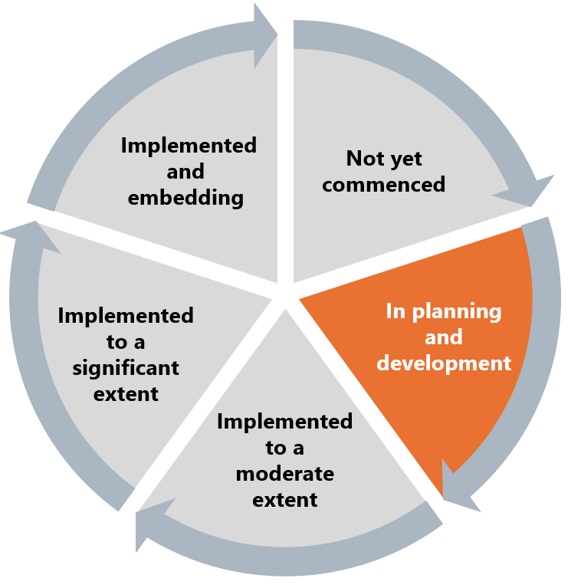

The Commission has assessed this recommendation as in the planning and development stage.

Recommendation 9 is part of a group of recommendations (Recommendations 1–12) aimed at working towards a holistic approach to prevention. Recommendations in this group centre around:

* restoring trust
* strengthening prevention
* resetting organisational values
* encouraging a ‘speak up’ culture
* having ECOs and change champions
* valuing those who care
* sharing accountability for embedding workplace equality.

The Progress Evaluation Audit data identified some broader workplace issues around trust, accountability and psychological safety that may be acting as barriers to fully delivering the intent of this recommendation. Work to improve trust, accountability and psychological safety should be conducted in tandem with work to promote the Reform Enabler: Culture of Prevention.

Psychological safety has been identified in research as an important part of successful organisational change;[1] therefore these concerning results are likely to present a barrier to implementing this and other recommendations.

Given that part of the role of a champion is to represent, support and advocate for the reforms, the Commission considers that low levels of workforce trust and confidence in the delivery of the required reforms are likely to present barriers to both people’s willingness to take on a champion role and their being listened to by the workforce.

Low levels of reported trust in, and accountability of, senior leadership mean that reform communication may not be as well received from this group at this time. Similarly, low levels of reported psychological safety may negatively impact the confidence of both champions and ECOs to raise with senior leaders any risks they identify through performing their roles.

## What measures are still needed?

A focus on work to restore trust, accountability and psychological safety will enable champions to be a more effective part of ongoing reform work. Until this is underway, consideration should be given to how and when the champions element of this recommendation is further implemented. In particular, Ambulance Victoria should consider which members or groups of the workforce would be broadly seen as trusted sources of information and advocacy.

As the broader workforce is feeling that little change is being seen on the ground despite reform work to date – see Reform Barrier: Change Management Approach – and that psychological safety is low – see Recommendation 6: Improving safety in isolated environments – workforce members with low power (for example, the SRG) are likely not a safe or effective choice of champion at this time.

The pilot ECO program should provide Ambulance Victoria with strong information pathways and useful data to plan and refine the program further. As the ECO pilot program is reviewed and further developed, consideration should be given to how the program can build trust with staff and meet the needs of different workforce cohorts.

Contact officers and local champions networks play pivotal roles in enhancing and modelling workforce commitment. Work to implement Recommendation 9 will therefore have clear benefits to the Reform Enabler: Workforce Commitment.

1. Simon L Albrecht, Sarah Furlong and Michael P Leiter, ‘The psychological conditions for employee engagement in organizational change: Test of a change engagement model’ (2023) *Frontiers in Psychology* 14 <https://www.frontiersin.org/journals/psychology/articles/10.3389/fpsyg.2023.1071924/full>.