# Recommendation 8: Encouraging a ‘speak up’ culture

Recommendation 8 requires Ambulance Victoria to encourage a ‘speak up’ culture in its prevention plan, which is required to be developed by Recommendation 3: A holistic evidence-based prevention plan. Recommendation 8 states that the prevention plan should outline options for bystander actions and emphasise the importance of bystander actions as well as bystander supports.

Recommendation 8 also requires Ambulance Victoria to incorporate the Upstander program into its regular training curriculum and have at least 75% of the workforce complete it within 2 years of the publication of Volume II of the Phase 1 Report. Lastly, it stresses the importance of aligning the revised complaint policy with the comprehensive prevention plan, ensuring it recognises the significant role bystanders play.

## Recommendation intent and why it matters

People who raise concerns about unlawful and harmful conduct help workplaces by enabling them to see and understand the conduct and what needs to be done about it. This reduces the risk of harm and stops it before it occurs.

A culture where people speak up creates a safer workplace. Encouraging people to raise issues will help Ambulance Victoria to discharge its duties under the *Equal Opportunity Act 2010* (Vic) to prevent, identify and respond to unlawful workplace conduct.

## Findings

### What we found in Phase 1 of the Review

In Phase 1 of the Review, the Commission discovered that a significant number of research participants had witnessed unlawful conduct at Ambulance Victoria and that the low rate of bystander reporting and fears of victimisation had perpetuated a culture of silence. The Commission identified crucial steps needed to address these issues, including removing barriers to reporting and adopting a strategic, integrated approach to foster a ‘speak up’ culture.

### What we found in Phase 3 of the Review

**The Commission found that Ambulance Victoria had missed opportunities to encourage a ‘speak up’ culture**

The Commission has found that Ambulance Victoria has missed opportunities to develop a ‘speak up’ culture as a result of its prevention plan not being finalised within 6 months of the publication of Volume II of the Phase 1 Report and the complaints policy not sufficiently recognising the role of bystanders. Without these necessary foundations, levels of incivility have remained high and the workforce is inadequately supported to act as bystanders.

**The Prevention Strategy does not adequately fulfil the requirements of part (a) of Recommendation 8**

In August 2024, the Board approved the Prevention Strategy: Targeting Workplace Discrimination, Sexual Harassment, Bullying and Victimisation (Prevention Strategy) (see Recommendation 3: A holistic evidence-based prevention plan).

A flow diagram on page 13 of the Prevention Strategy briefly outlines some suggested action options for bystanders to unlawful and harmful workplace behaviour. This seems to be an attempt to address parts (a)(i) and (ii) of Recommendation 8. Available support services for bystanders (part (a)(iii)) are only referenced generally in Appendix B of the Prevention Strategy. As noted in the assessment of implementation of Recommendation 3, the Commission is concerned that following the advice on page 13 of the Prevention Strategy, in the absence of supporting education and tools (including the Upstander program), may create a risk of harm to the bystander – the Commission has previously advised Ambulance Victoria of these concerns during Phase 2.

**Ambulance Victoria’s revised complaint policy does not recognise the role of bystanders**

Ambulance Victoria’s complaints policy outlines the principles and processes for managing and resolving internal complaints. It details the responsibilities of managers and includes a reference to supporting all staff involved in the complaint process, including complainants, respondents and witnesses. However, there are no further references to witnesses, nor are there any mentions of bystanders in the policy.

**At the time of the Progress Evaluation Audit, the Upstander program had not been embedded into a regular training program**

Ambulance Victoria had not embedded the Upstander program into the regular training program at the time of the Progress Evaluation Audit. The Commissioner understands that Ambulance Victoria intends to release the Upstander program in financial year 2025.

**Ambulance Victoria’s workforce has reported continuously high rates of incivility**

During the Progress Evaluation Audit, the Commission heard that high levels of incivility are being reported both informally and through the Professional Standards and Behaviours Department (PSBD). This is detailed further in Recommendation 13: A victim-centred and fair report and complaint system, Recommendation 14: Enhancing perceptions of independence and supporting capability for the new organisational response to reports and complaints of unlawful conduct and Recommendation 15: Supporting staff to confidentially report through anonymous pathways, and supported by staff feedback during the Progress Evaluation Audit:

Incivility is still active and live at the moment. And we sit here and we say that all the recommendations have come in and that some have been actioned and some haven’t. But I think we can't move away from the fact that incivility is still there and it's being somewhat managed slightly better, but it hasn't significantly shifted and in pockets it's still as strong as it's ever been, even with VEOHRC coming in, even with the level of communication and discussion being had.

Participant

**Ambulance Victoria is not adequately supporting the workforce to act as bystanders**

The Commission heard that the workforce is not equipped or supported to identify, act on and address unlawful or harmful conduct they witness.

The prevention plan and Upstander program should have been rolled out alongside the PSBD – not as separate pieces of work. But the prevention plan is yet to be rolled out and the Upstander program is still unclear in rollout timing/scope/resourcing.

Participant

### Progress in achieving change

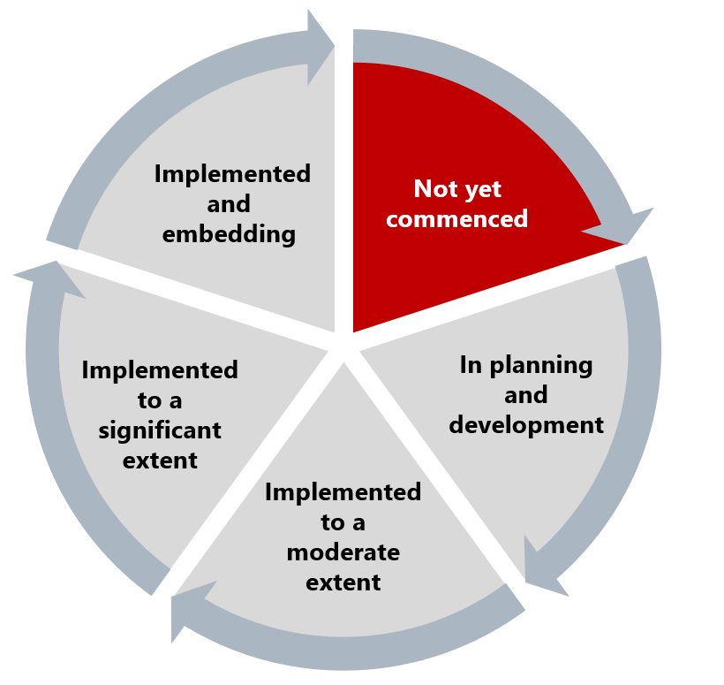

At the time of the Progress Evaluation Audit, the Commission found that this recommendation has in effect not yet commenced. The Prevention Strategy does not meet the requirements of part (a) of the recommendation and may currently pose a risk to bystanders because Ambulance Victoria has not yet adequately trained its workforce on how to act as bystanders. The complaints process does not include necessary references to bystanders and their role in upholding the organisation's standards of behaviour, nor their links to organisational values.

Without these measures, Ambulance Victoria cannot sufficiently support its workforce to identify, act on and address any unlawful or harmful conduct they witness.

## What measures are still needed?

The Commission encourages Ambulance Victoria to take several critical steps to meet the requirements laid out in Recommendation 8 and its associated recommendations. Most significant to meeting the recommendation’s intent will be the rollout of the Upstander training program.

A review of the bystander content of the Prevention Strategy is required, as is an explicit acknowledgement of the role of bystanders in the complaints policy, including a clear description of how they will be protected from harm and the importance of their contributions to upholding organisational standards.

Work to establish a culture of prevention will also assist Ambulance Victoria in fostering an environment where concerns are freely voiced, encouraging a ‘speak up’ culture (see Reform Enabler: Culture of Prevention). Without these measures, the organisation will continue to struggle with high levels of incivility and inadequate support for staff witnessing misconduct. See Reform Enabler: Enhancing Communication.

Safe reporting mechanisms are vital if Ambulance Victoria wishes to address racism experienced by staff. See Reform Barrier: Archetypes – Diversity and Inclusion.