# Recommendation 12: Supporting robust governance and oversight of reforms

Recommendation 12 requires Ambulance Victoria to establish a steering committee of specified internal and external representatives to monitor and oversee implementation of the Commission’s recommendations and broader organisational reforms.

## Recommendation intent and why it matters

The steering committee of internal and external experts is intended to:

* form part of a governance structure that will support and drive effective implementation of the Commission’s recommendations
* be a forum for monitoring and oversight of the progress of reforms and discussion of any areas of concern relating to implementation
* be an avenue for advice and guidance on reforms and projects to ensure they align with the intent of the Commission’s recommendations
* ensure accountability and continued improvement towards workplace equality to help Ambulance Victoria to prevent, identify and respond to unlawful conduct in line with the *Equal Opportunity Act 2010* (Vic) and other legal obligations.

## Findings

### What we found in Phase 1 of the Review

The Commission found that a dedicated steering committee would be important to provide ownership and responsibility for implementation and a singular line of oversight over reforms.[1] See section 6.2.7 of the Phase 1 Report.

The Commission considered that key organisational executives should be part of the steering committee to support the organisation-wide approach and reinforce the responsibility of all senior leaders for workplace equality.

Collaboration and effective stakeholder engagement are necessary for effective reform implementation. The Commission considered that employee and first responder representatives should be involved in the steering committee to contribute perspectives and support the transparency of workforce reforms.

Given the critical role that unions, professional associations and the Department of Health play in supporting Ambulance Victoria’s efforts to better prevent and respond to unlawful and harmful conduct, these organisations should be part of the steering committee.

Given the breadth, complexity and wide-ranging nature of our recommendations, the Commission considered that there would be significant benefit in ensuring the steering committee is equipped with senior external perspectives and expertise in leading practice responses to equal opportunity issues, responses to bullying, restorative engagement and restorative practices, as well as organisational development and change.

### What we found in Phase 3 of the Review

**Ambulance Victoria had changed its workplace reform governance structure several times since the Commission’s Phase 1 Report**

In January 2022, Ambulance Victoria established the Equality and Workplace Reform Steering Committee of internal and external experts including union representatives. The Committee was responsible for managing risk, resolving issues, coordinating dependencies and decision-making as required to facilitate successful project delivery.

In August 2022, this structure was replaced with a new governance model when Ambulance Victoria established 5 Pillar Governance Committees across the areas of safety, leadership development and values, governance and accountability, flexibility, diversity and inclusion, and complaints. Each committee was responsible for managing risk, resolving issues, coordinating dependencies and decision-making as required to facilitate successful project delivery.

In November 2023, Ambulance Victoria again changed its governance structure to the current Your AV model. The Your AV governance model consolidates the Pillar Governance Committees into the Your AV Steering Committee. The Your AV Advisory Group was also established at this time.

**Ambulance Victoria does not currently have a dedicated steering committee of specific internal and external experts to monitor and oversee reforms**

Ambulance Victoria’s Your AV Governance model includes the Your AV Steering Committee and the Your AV Advisory Group.

The Your AV Steering Committee meets every 6 weeks and includes Ambulance Victoria directors and executive directors. The Your AV Steering Committee terms of reference state the Committee has been established to provide whole-of-program oversight and formal ‘steering’ of the Your AV program delivery. The terms of reference describe the committee’s purpose as:

*‘overall program accountability, responsible for monitoring outcomes and progress made, while steering program implementation, strategy and scope, and the resolution of risks and issues.’*

The Your AV Advisory Group meets quarterly and includes external members who have specialist expertise in driving workplace equality reforms, including union representatives and leaders from other government and non-government organisations, as well as workforce representatives from the Your AV Staff Reference Group. The Your AV Advisory Group terms of reference state that it was established to provide strategic advice on how to drive long-term organisational change and workplace reform, including alignment with recommendations made by the Commission. The terms of reference go on to say that the Group’s role is to:

*‘strategically advise on embedding and sustaining workplace and cultural change backed by evidence, lived experience and specialisation around the gendered and intersectional drivers of violence and harm in workplaces, and lessons learnt in driving reform in complex workplaces or health contexts. This may include providing expert advice on implementation activities and opportunities to innovate and collaborate to support long term organisational change and workplace reform.’*

The Commission has found that while the mandate of the Your AV Steering Committee meets the intent of Recommendation 12, importantly the membership of the Your AV Steering Committee does not align with the recommendation. In contrast, the Your AV Advisory Group has the membership intended by the recommendation but lacks the envisioned mandate.

The Commission has not found evidence of how the Your AV Steering Committee and the Your AV Advisory Group work together.

### Progress in achieving change

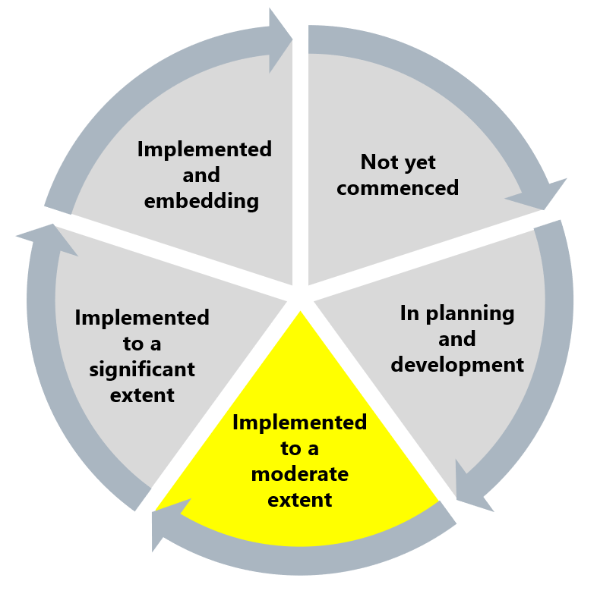

The Commission has assessed Ambulance Victoria’s progress towards implementing Recommendation 12 as implemented to a moderate extent. The Commission has flagged this recommendation due to concerns about the implementation approach that Ambulance Victoria has taken to date.

Although Ambulance Victoria has made progress towards implementing this recommendation, the Commission has found that the current implementation approach does not adequately deliver the recommendation intent of a steering committee of specified internal and external members with a mandate to monitor and oversee reforms. The Commission considers that a steering committee with this membership and mandate combination will be integral to ensuring ongoing reform accountability and continued improvement towards workplace equality in Ambulance Victoria.

## What measures are still needed?

The Commission encourages Ambulance Victoria to reconsider and alter the implementation approach to establish a dedicated steering committee that has both the mandate outlined in Recommendation 12(a) and the membership outlined in Recommendation 12(b).

By making these course corrections and establishing a robust governance committee with oversight of reforms in alignment with the recommendation, Ambulance Victoria can harness the Reform Enabler: Workforce Commitment by involving members of the workforce in the steering committee. Altering the implementation approach as suggested would also significantly impact the Reform Barrier: Change Management Approach. A robust governance committee will have clear accountability and oversight of reform change and can use its bird’s-eye-view perspective to identify potential change-management issues and enable continuity.

A dedicated steering committee with both the identified mandate and membership can also promote work to embed the organisational values as part of Recommendation 7: Resetting and embedding organisational values.

1. Victorian Equal Opportunity and Human Rights Commission, Independent Review into Workplace Equality in Ambulance Victoria: Phase 1 (Volume I, 2021) 348.