# Recommendation 13: A victim-centred and fair report and complaint system

Recommendation 13 focuses on developing a new model for responding to reports and complaints of discrimination, sexual harassment, bullying and victimisation that draws on leading practice. The Commission advised that the new complaint process should separate the key functions of the report and complaint system – including providing supports for victims, a dedicated, impartial and fair complaint-handling unit, and a specialist investigation unit.

## Recommendation intent and why it matters

Everyone has a right to feel safe and respected at work, and to feel confident to speak out and report experiences of unlawful or harmful conduct. A person-centred and fair report and complaint system will support Ambulance Victoria to effectively respond to unlawful conduct.

Rigorous report and complaint systems and processes are key to preventing and responding to workplace discrimination, sexual harassment, bullying and victimisation. Safe reporting systems are key in reducing the rates of discrimination, including racism, that the Commission heard about during the Progress Evaluation Audit. See Reform Barrier: Archetypes – Diversity and Inclusion.

They also have a role in visibly setting a standard of behaviour and promoting the Reform Enabler: Culture of Prevention through holding people accountable for harmful conduct.

## Findings

### What we found in Phase 1 of the Review

This recommendation arose because of an identified need to more comprehensively address the issues and barriers to staff feeling safe to come forward with reports and complaints.

The Commission found that a large proportion of the workforce reported experiencing unlawful and harmful behaviour, but only a small percentage made formal reports. When people did report, they ‘overwhelmingly’ described that the experience did not make them feel safe and that they were often left without support and were further traumatised by the process. The Phase 1 Report indicated that a range of measures and consistent, sustained effort would be needed to rebuild the trust and confidence of employees and first responders.

### What we found in Phase 3 of the Review

**Ambulance Victoria has established a new organisational response to reports and complaints of unlawful and harmful conduct in the Professional Standards and Behaviours Department (PSBD)**

The Commission found that a new complaint system is in place and had been operational for a year at the time of the Progress Evaluation Audit, through the establishment of the PSBD, which replaced the former Professional Conduct Unit (PCU). Ambulance Victoria provided evidence that the workforce and unions were consulted during planning for the PSBD. The PSBD is one of the most significant contributions to workplace reform.

The establishment of the PSBD was generally viewed as a positive outcome of the reforms by interview and focus group participants, and an improvement on the PCU. In particular, interview and focus group participants considered that the PSBD change-management approach has been more effective than some change-management approaches which Ambulance Victoria has utilised in other reform areas. See Reform Barrier: Change Management.

Improved complaint management was the second-highest ranked response grouping to the workforce survey question ‘What are the most significant positive changes that you have seen/experienced because of steps Ambulance Victoria has taken to reduce harmful and unlawful conduct?’

In terms of implementing some of the successes, that I think the biggest one has to be the establishment of the Professional Standards Department. So obviously that's really focusing on some of the more pointy-ended stuff and significant concerns that were raised, but a really important part to get things moving and showing intent.

Participant

**The Intake, Response and Support team within PSBD** **functions as a workplace harm unit**

This team within the PSBD provides the first point of contact for reports and complaints of unlawful and harmful conduct. The Commission understands that in triaging complaints, an intake officer assesses the safety and wellbeing of those involved. Any risks identified are raised with the senior intake manager for further action. Complaints which are assessed as being in scope are then referred to a case manager.

Ambulance Victoria told the Commission that during the initial contact between PSBD case managers and complainants, case managers discuss the details of the complaint, the PSBD’s processes and the various complaint management pathways available. The case manager also asks what outcome the complainant is seeking. The case manager then presents the complaint at the PSBD’s Assessment Committee,[1] which decides on a recommended complaint resolution pathway.

The PSBD Operating Manual (draft version 0.4) outlines the external bodies to which matters may be referred (for example, APHRA, Victoria Police, IBAC, among others).

**Informal resolutions using flexible dispute-resolution and restorative practices are an option for complainants**

Ambulance Victoria told the Commission that the Assessment Committee, which recommends a resolution pathway, balances a complainant’s wishes with Ambulance Victoria’s obligation to ensure a safe workplace for all workers and other legislated obligations. The Assessment Committee also considers the complainant’s willingness to participate in a complaint-resolution process, which may not be their first choice. In some cases, the Assessment Committee may choose not to proceed with a particular pathway because it is unable to ensure a fair process if further information is not provided by the complainant. Complaint-resolution options are:

* line manager (or other trusted manager) resolution including informal discussion, conduct reminder, formal counselling, performance/behavioural improvement plan
* mediation including facilitated discussion, formal mediation, shuttle mediation or any other format that suits the needs of the parties involved
* investigation
* referral to another Ambulance Victoria department.

In some cases, resolutions may involve the respondent offering an apology to the complainant.

Restorative practice is a strategy that seeks to repair relationships that have been damaged, including those damaged through bullying. It does this by bringing about a sense of remorse and restorative action on the part of the offender and forgiveness by the victim.[2]

During the Progress Evaluation Audit, Ambulance Victoria advised the Commission that restorative practices are used for complaints – giving the example of the high numbers of referrals of complaints back to local area management, where strategies including performance improvement, reflective practices, emotional intelligence training, coaching or referral to an organisational psychologist are used. Contrastingly, the workforce told the Commission in interviews and focus groups that there is a general lack of accountability for perpetrators and a lack of transparency around outcomes for substantiated complaints. The Commission did not get a sense from the workforce that restorative practices that engender remorse, humility, acknowledgement of behaviour (and other restorative actions) are embedded in complaint resolution once a complaint has been substantiated.

The Commission notes that the establishment of an independent restorative engagement scheme was the subject of Recommendation 2, which is not in scope for the Progress Evaluation Audit.

**Reporting and complaint policies and procedures are available to the workforce**

Evidence provided by Ambulance Victoria showed that the Complaints Policy (POL PAC 070) and Complaints Procedure (PRO PAC 080) had been updated as part of the formation of the PSBD. Workforce survey results showed that just over half of respondents (60%) were confident they would be able to find complaint-handling policies. See Recommendation 16: Embedding a victim-centred approach to processes and procedures, which relates specifically to the Complaints Policy.

**The PSBD has started to collect and analyse data to identify trends and emerging risks**

Ambulance Victoria has told the Commission that its Policy and Research team analyses data, identifies trends and areas requiring support, and addresses systemic issues to prevent harm. The team monitors the PSBD’s performance against design standards, ensures compliance with legislation and remains updated on emerging risks and practices.

From the documentation provided, the director PSBD and senior policy and research manager roles have responsibilities to be advocates for leading practice complaint handling and standards within Ambulance Victoria. Data collection at the time of the Progress Evaluation Audit included:

* a confidential and optional participant survey – sent upon closure of a report or complaint to key stakeholders involved; the PSBD leadership team meets monthly to talk through survey response feedback
* work by the Assessment Committee to identify and record the underlying individual and organisational drivers of alleged behaviour and conduct
* a regular Professional Standards Performance and Insights Report which details matters including the number and type of cases in the reporting period, complainant data by role type and region, resolution pathways, case status and an overview of participant feedback.

The PSBD is also collecting data against service level goals for the 12 months commencing April 2024, with a view to establishing performance benchmarks in 2025 (for further information, refer to Recommendation 20: Understanding how the report and complaint system is working).

The PSBD reports quarterly to the People and Culture Board Committee, the Complaints Pillar Governance Committee (the CEO chairs this committee) and the Executive Committee.

**A separate specialist support unit has not been established under the PSBD structure**

Ambulance Victoria did not establish a specialist support unit to provide advocacy and direct support for those who have experienced unlawful and harmful conduct as required by part (b) of this recommendation. Rather, this function was merged into the responsibilities of case managers and psychologists in Ambulance Victoria’s Wellbeing and Support Services. At the time of the Progress Evaluation Audit, the PSBD structure comprised 3 senior case managers and 3 case managers who reported to the senior manager, Intake, Response and Support.

Ambulance Victoria told the Commission that the rationale for this approach was based on consultation feedback and reflects:

* a desire to increase the number of case managers in the PSBD structure
* that the introduction of a specialised advocacy and support unit within PSBD could create scope confusion because many individuals require assistance with complex issues that may not fall within the PSBD’s scope of behaviour and conduct
* that rather than separate teams within the PSBD with responsibility for support and advocacy, having a single point of contact via a case manager was considered to better support a person-centred, trauma-informed approach
* that including an advocacy service for complainants only within the PSBD was considered likely to undermine the perception of fairness of the PSBD across the workforce.

Although the Commission found broad positivity about the creation of the PSBD, it also heard mixed experiences of the support role provided by case managers. For example, some members of the workforce told the Commission that they had had to re-explain their complaint to multiple case managers or multiple times, which is inconsistent with trauma-informed practice. Further, some members of the workforce said they had experienced different case managers across the course of their complaint and others felt their case manager’s communication had been insufficient in that they did not hear from their case manager for several weeks at a time.

Thirty per cent of workforce survey respondents who reported having made complaints to the PSBD were satisfied with the support provided to them by their case managers. Satisfaction was lower among operational roles including ambulance paramedics with less than 12 months experience and Mobile Intensive Care Ambulance (MICA)/MICA flight paramedics.

**Ambulance Victoria has established an Investigations Unit**

At the time of the Progress Evaluation Audit, the Investigations Unit comprised a senior manager Investigations, 2 principal investigators and 2 senior investigators. Ambulance Victoria’s PSBD Operating Manual (draft version 0.4) outlines that when an allegation of misconduct or serious misconduct (for example, a breach of the AV Code of Conduct, AV policies or procedures, Victorian Public Sector Code of Conduct or legislation) is identified and local resolution is not appropriate, a complaint may be managed through a misconduct process including an investigation of the alleged conduct.

Position descriptions for these roles include a requirement for ‘experience in undertaking complex and sensitive victim-centric investigations consistent with relevant legislative and industrial requirements and demonstrated knowledge and understanding of workplace investigations and development of effective resolution strategies’.

**Despite work to implement Recommendation 13, workforce experiences do not reflect the realisation of a safe and effective report and complaint system**

The Commission found that there are a number of barriers to the realisation of the intent of this and other complaint-related recommendations, which include the following:

* Trust in the report and complaints system is very low – only 15% of survey respondents agreed that since the introduction of the PSBD they trust that complaints will be managed well.
  + This is particularly the case for Advanced Life Support paramedics and MICA/MICA flight paramedics. Trust is also very low among respondents with disabilities and First Peoples. Contrastingly, non-operational staff reported higher levels of trust.

Satisfaction is low across time, fairness, support, communications and outcomes of the complaint system, as shown in the following graph, which summarises survey responses from respondents who had made complaints to the PSBD.

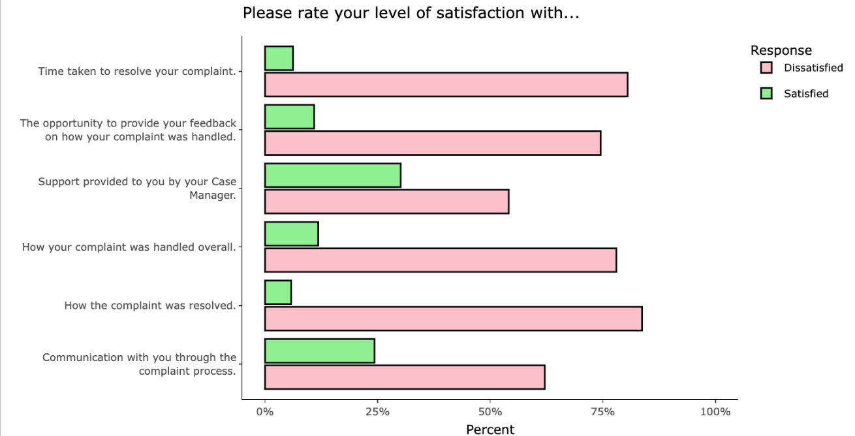

I just wonder if it would be that the PSBD should be doing a six-month follow-up. If they can't, obviously there are some privacy issues, but a follow-up email or contact to a complainant that just says, just checking that everything is going okay and you haven't got further issues. Because I feel like what happens is when you don't get an outcome, and most people don't get an outcome, is that shutter is drawn and people then are concerned that they can't then re-raise an issue.[3]

Participant

### Progress in achieving change

The Commission has assessed this recommendation as implemented to a significant extent but has flagged the implementation approach for Ambulance Victoria to reconsider, given the barriers to the realisation of the intent of this and other complaint-related recommendations, as outlined above.

In terms of the activities required to deliver this recommendation, the structure for the PSBD has been established and it is working to address current and historical complaints. The Commission heard of a strong desire for an effective, person-centred and trauma-informed PSBD from organisational leaders. During data collection the Commission found evidence of continuous improvement practice that will support the ongoing refinement of the PSBD’s operations.

However, at the time of the Progress Evaluation Audit, the principles underpinning an effective report and complaint system listed in Figure 7C[4] in the original Review Report were not fully realised. See also Recommendation 16: Embedding a victim-centred approach to processes and procedures and Recommendation 14: Enhancing perceptions of independence and supporting capability for the new organisational response to reports and complaints of unlawful conduct.

## What measures are still needed?

Refer to Recommendation 16: Embedding a victim-centred approach to processes and procedures for broader commentary about fully implementing the intent of all recommendations relating to the management of complaints at Ambulance Victoria.

In relation to Recommendation 13, in Ambulance Victoria’s continuous improvement practice, attention should be given to reviewing and reflecting on whether case managers are able to effectively fulfil the roles associated with supporting complainants and whether any changes to practice or structures are required.

In addition, further exploration of embedded restorative practices, including equipping local area managers with the capabilities to engage in these practices, will be of benefit to Ambulance Victoria.

1. The Assessment Committee members are: the senior manager intake and response (Chair); representative from Investigations; representative from AV Psychology; legal counsel; operational advisor; presenting case manager; senior advisor Specialist Support and Engagement; Director PSBD; and representative from Policy and Research team.
2. ‘Restorative practice’ (18 January 2024) <https://www.vic.gov.au/restorative-practice>.
3. The Phase 1 Report says, ‘it is also well documented in research and literature that a key element of addressing reports and complaints of unlawful conduct is that there is appropriate follow-up to address any potential ongoing issues’.
4. The features are: institutional culture; transparency and access; responsiveness and feedback; objectivity and feedback; objectivity and fairness; staff training and delegation; accountability; continuous improvement; right of review; and fair remedy.