# Recommendation 18: Developing resources to support accessibility of the report and complaint system

Recommendation 18 requires Ambulance Victoria to develop and make available comprehensive information guides and fact sheets that clearly outline the internal and external pathways for making a complaint, the support services available to all parties involved in the report and complaint processes (including complainants, respondents and witnesses) and what these parties should expect during the complaint process.

## Recommendation intent and why it matters

Improving the accessibility of information regarding complaint processes will help Ambulance Victoria to encourage reporting and create a safer workplace.

This approach is crucial for fostering a supportive complaint environment and ensuring that all individuals feel informed and confident in the process. It recognises the importance of providing clear and accessible information to ensure transparency and is essential to prevent and respond to unlawful workplace conduct.

By providing accessible information about its report and complaint system and processes, Ambulance Victoria will encourage reporting by:

* making it easier for individuals to understand how to make a report or complaint
* promoting a complainant’s choice and control through clearly articulated outcomes to support complainants to resolve their concerns, and
* explaining what can be expected.

## Findings

### What we found in Phase 1 of the Review

During Phase 1 of the Review, the Commission found that Ambulance Victoria had a number of policies and procedures describing varied complaint processes. This created ambiguity about the expectations and responsibilities for acting on, and responding to, unlawful behaviour.

*‘The Professional Conduct Procedure “strongly encourages” staff to “to do something about unacceptable behaviour”. Separately, the Code of Conduct outlines that all employees and volunteers are required to report conduct that is in breach of the law, the Code or other policies or procedures. Whereas the Professional Conduct Policy notes that Ambulance Victoria expects the workforce to lodge a complaint when “they believe they have witnessed/experienced significant unacceptable workplace behaviour”.’[1]*

### What we found in Phase 3 of the Review

**Ambulance Victoria has developed resources to raise awareness of the new Professional Standards and Behaviours Department (PSBD) complaint process which include most of the required information**

Ambulance Victoria has developed resources including posters titled ‘However you want to report it. We want to hear about it’ and ‘AV report and complaints process’ as well as a ‘PSBD resolution process’ infographic.

Guidance in complaint procedures includes the ‘We have received your complaint’ guide for complainants, as well as the ‘Guidance for respondents’ and ‘Guidance for witnesses’. These documents include information on what parties to a complaint should expect, including how quickly their complaint will be assigned, what information they will receive, expected standards of service and how their information will be handled.

The Commission found that, while the majority of the information required by Recommendation 18 has been included in the resources, the resources do not mention the external complaint pathways available, such as Fair Work, SafeWork or the Victorian Equal Opportunity and Human Rights Commission. As these documents will be subject to annual review, this information should be included in future iterations.

The Commission also notes that the resources do not include an estimation of the overall timeframe associated with a complaint. During the Progress Evaluation Audit, the Commission frequently heard of workforce dissatisfaction with complaint service timelines. It is important that Ambulance Victoria manages complaint timeframes and communicates average complaint timeframes in all resources about the PSBD complaint service. This will help to ensure complainants can make informed decisions and have reasonable timeline expectations before lodging a complaint. It will also assist respondents and witnesses in understanding what will be required of them during their participation in the complaint process, which is especially useful for complainants from multicultural backgrounds and First Peoples. This will promote agency and informed decision-making of complaint participants and may assist Ambulance Victoria in reducing the negative feedback received regarding complaint timeframes.

**Ambulance Victoria has provided guidance on the outcomes available to a complainant**

Guidance on complainant outcomes is contained in the ‘We have received your complaint’ guide for complainants, including a resolution and response pathways outcomes table.

**Ambulance Victoria has briefed leaders on the PSBD**

The Professional Standards Leader Pack briefs leaders on the reporting process, the role of leaders, delegations and responsibilities, involvement in conflict resolution, resolution pathways and possible outcomes, mandatory notifications and public interest disclosures, wellbeing and support.

**Ambulance Victoria has communicated and promoted the PSBD to the workforce**

Multiple branches have received presentations on the PSBD process; the role of leaders; delegations and responsibilities; involvement in conflict resolution; resolution pathways and possible outcomes; mandatory notifications and public interest disclosures; and wellbeing and support. Communications have also been disseminated to staff electronically, including through the AV News and Announcements forum.

The Commission found that guidance and resources on reporting and complaint pathways clearly promote PSBD services and encourage staff to raise complaints. The Commission found that resources are audience-specific, with individualised information for complainants, respondents, witnesses and leaders. The resources are informative and accessible to a wide audience.

So, we're not talking about complaints necessarily, but we're talking about the program that's established, the work that's gone into it, how people can connect to it, you know, that it's been effective, the feedback has been good.

Participant

Effective communication about complaint reforms plays a crucial role in driving positive change. Additionally, it is essential to communicate the availability of new resources that support these reforms. Providing information on new resources regarding the PSBD can empower the workforce to engage with the reforms more effectively and feel more confident in utilising the PSBD’s services. See Reform Enabler: Enhancing Communication.

### Progress in achieving change

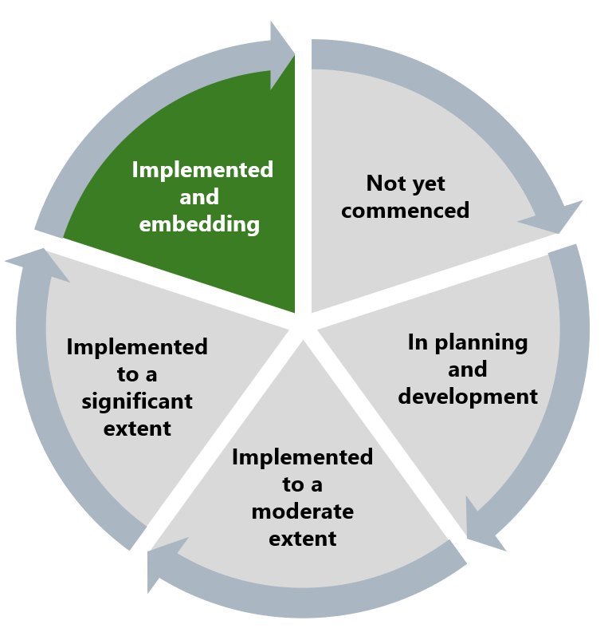

The Commission has assessed that the activities outlined in this recommendation have been implemented, and the recommendation intention of increasing awareness has largely been met and is being embedded. The timely development of accessible resources to support the complaint process is seen as a positive feature of Ambulance Victoria’s approach to change management in this reform area. See Reform Barrier: Change Management Approach.

## What measures are still needed?

As outlined above, the resources should outline external complaint pathways available to a complainant, such as Fair Work, SafeWork or the Victorian Equal Opportunity and Human Rights Commission. Further, the resources should also include an estimation of the overall timeframe to resolve complaints. As these documents will be subject to annual review, this information should be included in future iterations.

1. Victorian Equal Opportunity and Human Rights Commission, Independent Review into Workplace Equality in Ambulance Victoria: Phase 1 (Volume II, 2022) 380.