# Recommendation 25: Increasing diversity on the Ambulance Victoria Board

Recommendation 25 requires Ambulance Victoria to undertake steps to increase Board diversity. These steps include a Board diversity and skills matrix to assess and promote demographic diversity, as well as reporting annually on Board diversity and the work of the Board and the organisation to achieve workplace equality.

Recommendation 25 requires Ambulance Victoria to work with the Victorian Department of Health to collect demographic data on Board directors and to explore amending legislation so that diversity would have to be considered when Board appointments were made. It also requires the Ambulance Victoria Board to promote diversity in its annual Board evaluation and to report on aggregate gender and diversity composition of the Board in the annual report.

## Recommendation intent and why it matters

Diversity ensures strategic direction is set while considering a wider range of perspectives and experience, can help all directors to participate fully and meaningfully, and is critical for advancing diversity policies and practices at an organisational level. Importantly, role modelling diversity sends a clear message about a board’s commitment to equality and supports greater accountability for considering the perspectives of different groups.

Equal representation, diversity and inclusion among organisational leaders contribute to improved financial and operational performance, better decision-making and higher levels of innovation. This will ensure transparency, drive continuous improvement of Board diversity and support more effective delivery of ambulance services for the community.

## Findings

### What we found in Phase 1 of the Review

As at 31 March 2021, the Ambulance Victoria Board included four women ordinary directors and was chaired by a man. There was fair gender representation on the Board’s permanent committees.

Beyond gender, data on the diversity of the Ambulance Victoria Board was limited. Few individual directors had disclosed demographic information and the data available was not being used to understand the nature or extent of the Board’s demographic composition. As a result, it was not possible to determine the nature and extent of broader demographic diversity among the Board’s directors. This includes the extent to which the Board role models diversity through its composition or the extent to which Board discussions and decision-making are informed by the perspectives and lived experiences of individuals from diverse backgrounds or whether reasonable adjustments or accommodations are needed to enable directors to participate fully and meaningfully.

The Commission reported[1] that the Victorian Government Appointment and Remuneration Guidelines provide that appointments to Victorian Government entities should, as far as practicable, reflect the diversity of the Victorian community and the Department did collect demographic data about directors which, where disclosed, informed the advice provided to the Minister about candidate suitability. See section 10.2.1 of the Phase 1 Report.

### What we found in Phase 3 of the Review

**Ambulance Victoria has updated its Board diversity and skills matrix, and expanded the Board diversity demographic data it collects**

Ambulance Victoria has implemented the Victorian Government’s template Board skills and diversity matrix, which includes collecting information on Aboriginality, cultural and linguistic background, disability, gender, age group, sexual orientation and principal place of residence.

The matrix does not include data on religion as required by point (a) of Recommendation 40: Updating and strengthening governance documents.

The Commission notes that in addition to the Board diversity and skills matrix, Ambulance Victoria maintains a matrix for the Board Community Advisory Committee to ensure broad community representation.

The Ambulance Victoria Board Chair is required by the Department of Health to complete a survey in advance of annual Board recruitment which includes questions on diverse recruitment characteristics that should be prioritised to better reflect the Victorian community.

The Community Advisory Committee provides advice and direction to the Board on issues directly impacting the community.

The Board diversity and skills matrix enables Ambulance Victoria to understand the nature and extent of the Board’s demographic diversity.

**Ambulance Victoria’s 2022–23 Annual Report outlines Board demographic diversity but does not report on how the Board and the organisation have worked to promote and prioritise workplace equality**

As outlined in the 2022–23 Annual Report:

* 0% of the Board identify as Aboriginal and/or Torres Strait Islander
* 37.5% of the Board identify as being from culturally or linguistically diverse backgrounds
* 22.22% of the Board identify as persons with disabilities
* 66.67% of the Board identify as women and 33.33% identify as men
* 22.22% of the Board are aged 45–54, 33.33% are aged 55–54 and 44.44% are aged 65+
* 88.89% of the Board principally reside in metropolitan Melbourne and 11.11% reside rurally.

While this reporting does not include sexual orientation, the Commission notes this information is collected by Ambulance Victoria for internal data collection purposes in its diversity and skills matrix.

The Commission notes that while the Annual Report discusses the organisation’s work towards workplace equality, it does not report on how the Board and organisation have promoted and prioritised workplace equality as required by Recommendation 25.

During research for the Progress Evaluation Audit, Board members did not comment on what Board diversity brings to the work and decision-making of the Board.

**Ambulance Victoria has only undertaken limited work with the Victorian Government on diverse Board appointment law reforms**

The Commission has found limited evidence of Ambulance Victoria working with the Victorian Government to explore amending section 17(3) of the *Ambulance Services Act 1986* (Vic) to require the Minister to consider diversity when recommending appointments to the Ambulance Victoria Board.

### Progress in achieving change

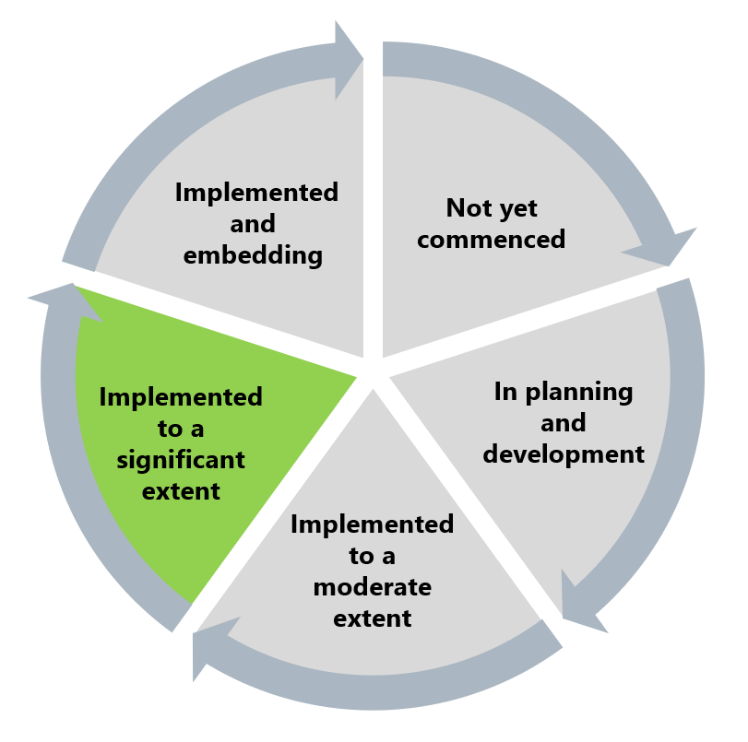

The Commission considers that this recommendation has been implemented to a significant extent. While Ambulance Victoria has delivered certain activities – including implementing a diversity and skills matrix, expanding the Board diversity demographic data it collects and reporting on this data in its annual reporting – scope to improve Board diversity and data collection and reporting remains.

Undertaking certain recommended activities including annual reporting on the Board’s workplace equality work and progressing work with the Victorian Department of Health to explore legislative amendment for Board diversity to be considered in recruitment should still be delivered to fully acquit this recommendation and ensure continuous improvement of Board diversity.

## What measures are still needed?

To fully implement this recommendation, Ambulance Victoria should progress advocacy and work with the Victorian Department of Health to explore amending legislation so that diversity would have to be considered when Board appointments were made. Ambulance Victoria should also include information on the Board’s and the organisation’s work to promote and prioritise workplace equality in the annual report each year.

During the Progress Evaluation Audit, the Commission heard that certain characteristics – including disability – were not seen as being valued at Ambulance Victoria. These perceptions are pervasive barriers to cultural change and public statements from the Board on how diversity enhances its work and decision-making would assist Ambulance Victoria in reducing the Reform Barrier: Archetypes – Diversity and Inclusion.

1. Department of Premier and Cabinet, ‘Ensuring good governance and transparency through integrity of data on Victorian Government appointments and public entities’, Administrative Guideline No. 2018/01 (Victorian Government, 2018), cited in Victorian Equal Opportunity and Human Rights Commission, Independent Review into Workplace Equality in Ambulance Victoria: Phase 1 (Volume II, 2022) 583.