# Recommendation 23: Supporting the effective delivery of reporting and complaint reforms

Recommendation 23 requires Ambulance Victoria to engage with a range of experts in complaint handling, unlawful conduct and restorative practices, as well as workforce and union representatives, to seek advice and support on report and complaint system reform implementation.

During Phase 2 of the Review, Ambulance Victoria and the Commission agreed on a different approach for implementing this recommendation to facilitate Ambulance Victoria flexibly meeting the recommendation intent. The variation provided for Ambulance Victoria to seek ad hoc advice from specified subject matter experts, unions and the workforce – rather than just establish an Expert Advisory Group.

## Recommendation intent and why it matters

Authoritative guidance and expert advice on reporting and complaint reforms will facilitate implementation of complex recommendations and ensure that the design and development of reforms are informed by workforce needs. Ultimately, this expert guidance will help to ensure people using Ambulance Victoria’s complaint system are treated fairly and with respect and dignity, which in turn will increase the identification and elimination of unlawful behaviours.

## Findings

### What we found in Phase 1 of the Review

The Commission’s workforce survey during Phase 1 of the Review demonstrated that many employees and first responders sought the advice of a union following an experience of unlawful conduct. The Commission found that unions play an important role in driving confidence in the report and complaint system, and are an important voice to include on the advisory group.

The Commission considered that expert advice and guidance would support the implementation of more complex aspects of complaint reform recommendations, including the development of informal reporting processes, which need to be carefully considered in certain contexts, such as sexual harassment. The Commission found that, in line with leading practice and the broader literature, advice should be sought from subject matter experts in complaint handling as well as representative members of the workforce. See section 9.6.1 of the Phase 1 Report.

### What we found in Phase 3 of the Review

**Ambulance Victoria has sought advice from independent subject matter experts on reporting and complaint system reforms**

Ambulance Victoria has engaged independent experts in complaint handling, unlawful conduct, restorative practices, process design, workplace and equality law, and implementation of large-scale workplace reforms. These independent experts have reviewed practices and processes, and advised on improvements to the reporting and complaint system in line with best practice. Advice has also been sought from health sector experts and Victorian Government stakeholders.

**Ambulance Victoria has sought advice from unions and members of the workforce on reporting and complaint system reforms**

Ambulance Victoria sought advice and guidance from members of the workforce on reforms to the reporting and complaint system during 2022 and 2023, including through the Equality and Workplace Reform Steering Committee and the Your AV Staff Reference Group.

Unions and workforce representatives were also consulted and provided Ambulance Victoria with advice and support on implementing reforms to the reporting and complaint system. This was evidenced through consultation documents and the communication plan to launch the new Professional Standards and Behaviours Department (PSBD) in 2023.

The delivery of the new report and complaint system was also supported by subject matter experts across Ambulance Victoria divisions including legal, digital and technology services, recruitment, organisational design, wellbeing and support services, procurement, enterprise project management, diversity and inclusion, workplace reform, communications and engagement, and operational advisory, among others.

**Ambulance Victoria has incorporated the advice of workforce and subject matter experts into reporting and complaint system reforms**

The Commission found that Ambulance Victoria applied the advice of the workforce, unions and subject matter experts to reforms to the reporting and complaint system, particularly to the development of the PSBD, including project management, system scope, accessibility, governance, processes, guidance and policy, AV SpeakUp anonymous reporting process design, categorisation and classification of complaints, decision-making hierarchy, investigation process and approach, risk assessment and management, and staff training. Stakeholders were also consulted on the transitional complaint model and were involved in user-accepted testing to ensure the effective implementation of the new report and complaint system.

### Progress in achieving change

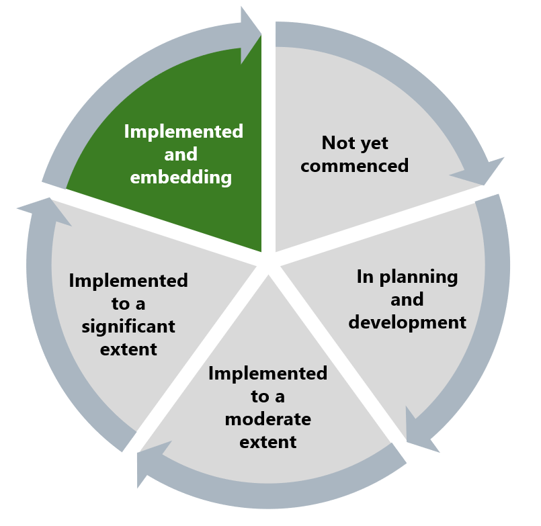

The Commission has assessed Ambulance Victoria’s progress towards this recommendation as implemented and embedding. The Commission considers that Ambulance Victoria has fulfilled the activities outlined in Recommendation 23 and delivered on the intent of the recommendation by ensuring that experts contributed to the development of reforms to the complaint system, which has been designed with the aim of a fairer, safer and more inclusive Ambulance Victoria.

## What measures are still needed?

The Commission encourages Ambulance Victoria to continue to engage a range of stakeholders when reviewing the operation of the reporting and complaint system, including on any changes to the system, to ensure it meets workforce needs and continues to reflect best practice.

The Expert Advisory Group has assisted Ambulance Victoria in addressing the Reform Barrier: Change Management Approach by providing consistency and stewardship through a number of key reform challenges.