# Recommendation 28: Removing structural barriers to career advancement

Recommendation 28 requires Ambulance Victoria to remove structural barriers to career advancement for paramedics, including compulsory managerial endorsement and considering of sick leave patterns, parental leave and working flexibly as barriers in the Recognition and Development process. It requires Ambulance Victoria to allow paramedics to complete the Mobile Intensive Care Ambulance (MICA) program while working flexibly.

## Recommendation intent and why it matters

Removing structural barriers to career advancement will limit discrimination and enhance workplace flexibility across all cohorts, supporting Ambulance Victoria to attract and retain talented staff, particularly women, carers and people of diverse backgrounds. To foster a more inclusive and equitable environment, it is essential to enable more women and individuals from diverse backgrounds to access MICA and career-progression opportunities. Additionally, removing policies that may have discriminatory impacts (such as those related to the Recognition and Development process and sick leave patterns) is crucial to ensure fair treatment and equal opportunities for all employees.

Organisations that value diversity can deliver more effective services. At a workforce level, diversity and inclusion support the delivery of responsive and sensitive services. Diversity and inclusion also improve organisational performance and culture, and reduce the risk of unlawful and harmful workplace behaviours.

## Findings

### What we found in Phase 1 of the Review

During Phase 1, the Commission found that Ambulance Victoria’s process for requiring managerial endorsement during recruitment for MICA positions created issues, including:

* risk of subjective and biased decision-making in recruitment
* individuals needing to foster close relationships with line managers to engender favour and endorsement, which increased existing power imbalances
* risk of reducing diversity through endorsement only going to managers’ peers or friends.

The Commission also found a lack of robust recruitment processes including selection criteria and structured review processes.

### What we found in Phase 3 of the Review

**Ambulance Victoria has commenced work to improve flexibility and diversity within the MICA program**

Ambulance Victoria has removed sick leave patterns and exemptions to the 12-month rule for employees working flexibly or on parental leave. Ambulance Victoria is also offering flexibility to MICA on-road trainees by aligning supervision requirements with minimum hours, which allows trainees to progress at their own pace and now allows interns to communicate variations that may impact training and assessment guidelines.

Ambulance Victoria has partnered with Monash University to sponsor students to study their Graduate Diploma of Specialist Paramedic Practice, which is delivered flexibly.

Ambulance Victoria has established the MICA Steering Committee responsible for assessing improvements to the MICA program and identifying opportunities for program improvement. The Steering Committee includes an identified position for a female MICA paramedic.

Ambulance Victoria has monitored and reported on MICA age and gender diversity. This includes the breakdown of male-to-female paramedics and the number of MICA paramedics who are on parental leave.

**Ambulance Victoria has made changes to career-progression processes**

The Commission found that Ambulance Victoria has replaced the Recognition and Development process with the Future Career Opportunities (FCO) program, which commenced in pilot phase in May 2024. This program will create a new suite of pre-endorsed candidates to fill acting, secondment or higher duties roles and replace the previous Recognition and Development process, reducing reliance on ad hoc expression of interest processes.

The program is described as being employee-led and participation is undertaken on an opt-in basis. The program is also described as incorporating de-identified assessment against agreed criteria, not requiring managerial endorsement and including guidance for election of appointments based on ‘criteria of order of merit and previous opportunities’.

**Ambulance Victoria has not yet removed all requirements for managerial endorsement across career advancement**

While Ambulance Victoria has stated that the FCO process does not include managerial endorsement, the Commission found in resources that describe the intake processes a suggestion that a de facto managerial endorsement process is in place.

Rather than just the normal probity check managerial reference taking place at the end of a recruitment round prior to the applicant being offered a role, the FCO process uses managerial input to determine whether an applicant is placed on the order of merit and is therefore considered for career-advancement opportunities.

In the FCO process, managerial input contributes to an applicant’s merit score, which determines whether they have met the minimum level required to be placed on the order of merit. The Commission considers this to be a de facto managerial endorsement process and Ambulance Victoria has not met the intent of this recommendation as a result.

**Ambulance Victoria’s workforce reported mixed views about the removal of managerial endorsement**

During the Progress Evaluation Audit, the Commission heard that the MICA selection process has improved and that it is now easier to get into the program.

The workforce reports a positive in that selection to get onto the MICA program. And … it was obviously one of the big callouts that led to the commencement of the report in the first place. So, I think that's a positive.

Participant

The Commission also received negative feedback regarding the removal of managerial endorsement throughout the Progress Evaluation Audit including that the approach taken by Ambulance Victoria was overzealous or that ‘the pendulum swung too far’.

The pendulum swung too far one way and I'm not sure why exactly it was interpreted in that way. So the kind of things that came out of that is, well, we can't provide feedback anymore. Instead of this is how to provide meaningful feedback or this is what the problems were with feedback in the past.

Participant

The Commission also heard that Ambulance Victoria had overcorrected the issue by removing managers completely from recruitment processes across multiple areas, citing the Commission’s recommendation as the reason for doing so.

I think that the amount of times I've heard people in that department say to me, our hands are tied, VEOHRC's recommended this or we can't do anything about it, VEOHRC's done this, is a copout because there are workable solutions to everything.

Participant

This indicates a mixed understanding of the true nature of changes to managerial endorsement among the workforce.

### Progress in achieving change

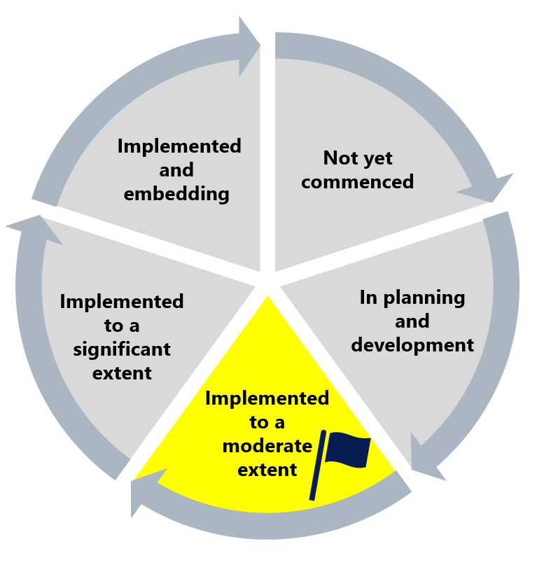

The Commission assesses Ambulance Victoria’s progress towards implementation of Recommendation 28 as implemented to a moderate extent. Although Ambulance Victoria has improved flexibility in MICA training and removed some managerial endorsement requirements, the Commission found some evidence that replication of managerial endorsement processes still occurs in reference checks, which appear to partially determine eligibility for shortlisting. Given this, the Commission has flagged the approach to this recommendation and encourages Ambulance Victoria to review its current implementation approach to ensure the recommendation intent is met.

## What measures are still needed?

Ambulance Victoria should support managers to participate in probity checks during recruitment. Managers should be free to participate in recruitment processes that do not duplicate managerial endorsement practices. Probity checks, which are generally conducted after an interview but before a formal offer is made, are the appropriate opportunity for managers to provide input on a candidate’s suitability.

The information provided on the MICA assessment procedures identifies opportunities for improving accessibility. The Commission heard about applications that had been rejected because they did not meet the formatting criteria. Ambulance Victoria could consider where inclusive assessment conditions should be introduced, such as allowing for non-written submissions and video assessments, extensions to examination times and so on.

Ambulance Victoria may also wish to consider the use of an order of merit within the FCO program to ensure it does not disproportionately impact particular cohorts such as people with caring responsibilities or people with disabilities.

**Improving flexibility at Ambulance Victoria**

Like most paramedics at Ambulance Victoria, MICA paramedics are subject to inflexible working conditions and rostering environments. For flexibility to improve in the MICA program, Ambulance Victoria should appropriately prioritise and resource the full-scale implementation of flexibility for the operational workforce. See Reform Barrier: Flexibility.