# Recommendation 31: Implementing and tailoring the Think Flex First Framework

Recommendation 31 requires Ambulance Victoria to fully implement and update its Think Flex First Framework, involve the People and Culture division in flexible working discussions, adopt the Victorian Public Service ‘all roles flex’ approach and support local flexibility strategies. This includes ensuring the new centralised division has the necessary resources and seeking government funding. These actions are crucial for embedding flexibility in the organisational culture, ensuring legal compliance, enhancing productivity, supporting gender equality and fostering innovation.

## Recommendation intent and why it matters

This recommendation aims to enhance workplace flexibility for all staff by improving attitudes and access to flexibility for all staff through consistent decision-making and embedded practice. It also seeks to ensure legally compliant and appropriate responses to flexibility requests through more support for managers and enhancing the role of People and Culture through increased funding and resources.

Implementing and tailoring the Think Flex First Framework will help women, people with disabilities, people with caring responsibilities and older workers, in particular. Supporting these cohorts will improve workforce diversity and ensure diverse leadership representation at Ambulance Victoria. Providing flexibility to parents, carers and pregnant workers removes barriers to women’s full and equal participation at work, which will in turn help Ambulance Victoria to address the under-representation of women in specialist clinical and operational management roles.

## Findings

### What we found in Phase 1 of the Review

In Phase 1 of the Review, the Commission found that Ambulance Victoria’s Flexible Working Arrangements Procedure emphasised compliance and operational needs over individual employee needs. Flexibility was formally defined as a change to employment conditions, with no reference to informal flexible working arrangements. Managers had full discretion to approve or deny flexible work requests and some managers failed to provide written responses or reasons for refusals, contrary to the *Fair Work Act 2009* (Cth) requirements. There was no mechanism to ensure legal compliance. During the COVID-19 pandemic, Ambulance Victoria effectively trialled new flexible working methods for both operational and corporate staff, although operational staff had less flexibility. The absence of accurate and comprehensive data capture on flexible working arrangement applications, timelines, approval and refusal bases, and appeal outcomes prevented Ambulance Victoria from determining non-compliance risks, fully assessing employees’ experiences or evaluating existing and new flexibility strategies.

The requirement to meet the shift-weighting calculator for approving flexible working arrangements was another barrier to flexibility for operational staff. Prioritising output over individual needs resulted in inadequate assessment and potential indirect discrimination. This negatively impacted current staff and limited Ambulance Victoria’s ability to recruit a future workforce expecting greater flexibility. Negative attitudes towards flexible and part-time work also created barriers to career progression, especially for parents, most of whom were women. Managers lacked the guidance, capacity, knowledge and autonomy to support increased flexibility, particularly for operational staff. The People and Culture division faced extreme pressure, lacking the time and resources to facilitate flexible work negotiations. Additionally, the Rosters Team often disregarded approved flexible work requests due to pressure to fill rosters.

### What we found in Phase 3 of the Review

**Ambulance Victoria is in the early stages of work to implement and tailor the Think Flex First Framework**

Ambulance Victoria has updated the Think Flex First Framework to the Flexibility @ AV Plan. Organisational plans and goals regarding flexibility are included in the 2022–2025 Gender Equality Action Plan and 2023–2028 Strategic Plan.

The Commission found that Ambulance Victoria’s progress towards improving workplace flexibility is still significantly below expectations. The Commission has not found evidence of Ambulance Victoria enhancing the role of the People and Culture division or obtaining required funding for full-scale implementation.

The Commission found that flexible working arrangements are still limited to people with particular characteristics (parents, carers and people with disabilities, among others) who are eligible for flexible work under Ambulance Victoria’s Enterprise Agreements and have a formal application approved. People who are granted Flexible Work Arrangements (FWAs) continue to report impacts hindering their career progression.

**Ambulance Victoria intends to deliver this recommendation through the Flexibility @ AV Plan, 2022–2025 Gender Equality Action Plan and 2023–2028 Strategic Plan**

The Flexibility @ AV Plan addresses some of the criteria included in Recommendation 31 including sub-parts (b) enhancing the role of People and Culture and (d) identifying options to increase flexibility, trialling and testing during enterprise bargaining. However, the Flexibility @ AV Plan lists sub-parts (a), (e) and (f) as being out of scope ‘due to internal delegation and budgeting considerations’. The flexibility framework is therefore seen to have been reviewed and updated in accordance with Recommendation 31; however, serious consideration should be given to its viability if the required resourcing is not assigned.

Ambulance Victoria’s Gender Equality Action Plan outlines the organisation’s planned approach to flexibility, including setting up a Flexible Working group to co-design an approach to improve access to flexible work arrangements. Similarly, the Strategic Plan outlines goals around flexible work which will improve staff safety, health and wellbeing.

**Ambulance Victoria is undertaking consultation and testing flexibility models**

Ambulance Victoria has undertaken preliminary consultation to understand workforce needs regarding flexibility. This included a survey of almost 1,000 operational employees and online briefings with 58 operational staff.

Ambulance Victoria has tested potential flexibility models, which included:

* People-Based Rostering pilot in Metro (Advanced Life Support (ALS)), MICA and rural (ALS and MICA)
* Advance Allocation pilot for Graduate Ambulance Paramedics (GAPs) allowing graduates to preference work location; while preference for geographical location of work is not a flexible work arrangement, the ability to select a preferred location reduces work commutes, which provides greater flexibility
* electronic FWA form trial, which would be expanded when new rostering software went live in November 2024.

The approach to piloting and trailing programs without broad organisational implementation is a recognised feature of the Reform Barrier: Change Management Approach which hampers reform progress.

**Ambulance Victoria has made progress towards improving workplace flexibility through changes to the MICA program, hybrid work arrangements and removing the Common End Date for regional FWAs**

Ambulance Victoria has delivered several projects which demonstrate progress towards meeting the intent of this recommendation, including:

* introducing flexibility into the MICA program: MICA has introduced pathways for clinical training including MICA Single Responder Units and Return to Work shifts. This is an important step to reduce career-advancement barriers for paramedics wanting to train in MICA and requiring flexibility. However, during the Progress Evaluation Audit the Commission consistently heard from operational staff that they did not feel the impacts of flexibility reform during their day-to-day roles. This was, in part, attributed to the inflexible nature of their rostering and inability to access flexible working conditions. Despite comprising most of the operational workforce at Ambulance Victoria,[1] women only make up 21% of the MICA workforce. The Commission encourages Ambulance Victoria to improve flexibility for all of the operational workforce – not only for MICA trainees – otherwise it may not significantly improve flexible working conditions for women working broadly across Ambulance Victoria.
* removing the Common End Date process for Flexible Working Agreements: By removing the Common End Date, employees can negotiate FWAs for up to 12 months starting on any roster cycle without the need to renegotiate their agreements more frequently than required. The Commission notes that this has only been implemented in regional areas as Metro staff do not have Common End Dates.
* introducing hybrid working arrangements for non-operational staff: As with the Advance Allocation pilot for GAPs discussed above, preference for geographical location of work – in this case, at home or in-office – is not a flexible work arrangement. However, the ability to select a preferred location reduces work commutes, which provides greater flexibility.

**Ambulance Victoria has not shown progress towards enhancing the role of its People and Culture division in the Flexible Working Arrangement application process**

Based on the documents provided to the Commission by Ambulance Victoria during the Progress Evaluation Audit, the Commission did not find evidence in Ambulance Victoria’s practices and policies of People and Culture representatives being able to involve themselves in flexible work conversations between employees and managers and to review all refusals. The Commission found that the role of HR Support and HR Hubs are described in the Flexible Work Arrangements Procedure as being to maintain records of applications and granting of flexible work arrangements, provide support and advice regarding flexible work arrangements to employees and managers, and adhere to legislative requirements. This does not align with the intent of the recommendation and Ambulance Victoria has not acquitted this component of the recommendation.

**Ambulance Victoria has established a MICA Steering Committee**

The Commission found that a MICA Steering Committee has been established by Ambulance Victoria to explore and test flexible work options.

The MICA Steering Committee is comprised of 16 executive and non-executive representatives and includes an identified role for a female MICA paramedic to promote accurate representation of the MICA workforce as well as diversity and inclusion.

The MICA Steering Committee has the necessary resourcing and capability to support and monitor the implementation of Recommendation 31(a)–(d), including reporting to the Executive and Board.

**Ambulance Victoria has not obtained the required funding to properly implement workplace flexibility reforms**

The Commission has not found evidence of Ambulance Victoria seeking funding support for the implementation of greater flexibility across operational areas. During the Progress Evaluation Audit, the Commission was informed by Ambulance Victoria that funding has not been secured to fully support the implementation of workforce flexibility.

This is of significant concern as the Commission heard that proposals put forward to resolve complex rostering matters are frequently declined due to inadequate funding.

There's a lack of operational understanding of the finance people making their decision, which then has significant impacts on our ability to deliver on flexibility.

Participant

**Ambulance Victoria has improved flexibility for some employees, but has not yet embedded flexible work across the organisation**

Introducing hybrid working arrangements for non-operational employees is a noted improvement in the working conditions for non-operational staff.

The hybrid working model has progressed, but it's not related to operational employees, it's only related to corporate employees. So then operational employees all going well, they're doing work on that, but what does that mean for us? And so there is a lot of frustration from operational employees.

Participant

Hybrid work arrangements are a recognised feature of flexible work and are becoming increasingly normalised following the COVID-19 pandemic. Hybrid work arrangements are one piece of the puzzle and should be combined with other flexible work options such as compressed hours and job-sharing, among others. The Commission acknowledges that operational employees are unable to access hybrid work arrangements due to the on-road nature of their roles.

Ambulance Victoria’s workforce has shown an awareness of the benefits of flexibility and an openness to facilitating formal flexible working agreements for parents, carers and people with disabilities. During the Progress Evaluation Audit, the Commission heard that, largely, people who are seen to genuinely require flexibility – and who regularly demonstrate this requirement through complex application processes – are provided with flexible working agreements. The workforce also told the Commission about frequent flexible working refusals due to operational requirements.

There is a continuing and persistent view throughout Ambulance Victoria that 24/7 emergency response is incompatible with an ‘all roles flex’ approach. This is a feature of the Reform Barrier: Flexibility.

### Progress in achieving change

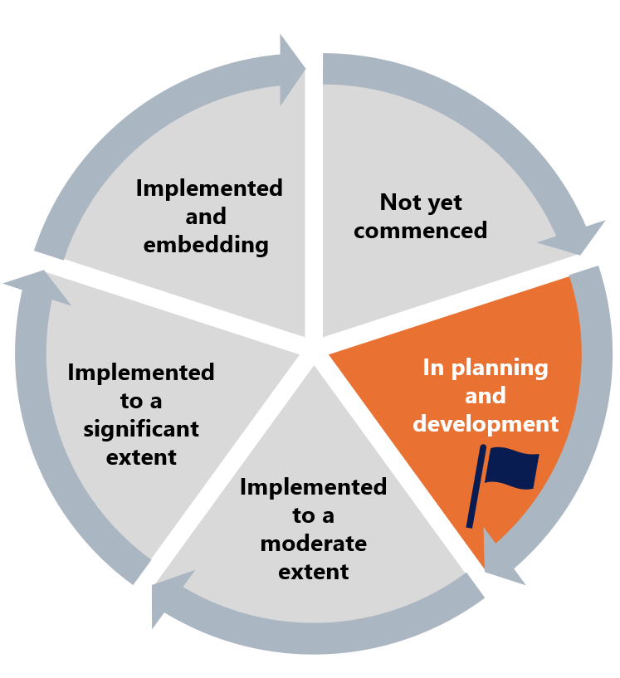

The Commission has assessed Ambulance Victoria’s work to implement Recommendation 31 as in planning. The Commission has flagged this recommendation due to concerns about the implementation approach taken to date. The Commission encourages Ambulance Victoria to reconsider its approach to implementation of Recommendation 31, given that significant work is required to remove barriers to flexibility in order to achieve the intent of this recommendation.

## What measures are still needed?

Ambulance Victoria states that its implementation of the recommendation will be achieved by 2027. To achieve this, Ambulance Victoria will need to adequately prioritise and resource large-scale implementation of an ‘all roles flex’ approach. Ambulance Victoria should also prevent unlawful discrimination and ensure reasonable adjustments are made through a robust reasonable adjustment policy as required by Recommendation 34: Creating reasonable adjustment policies, expertise and strategy, which is not one of the priority recommendations included in this Progress Evaluation Audit.

**Resolving structural issues**

Structural issues including the payroll system and rolled-in rate are entrenched barriers to flexible work reforms (see Reform Barrier: Rigid Structural Environment). The Commission encourages Ambulance Victoria to prioritise and resource work in this area to progress reforms and improve workplace equality. See Reform Barrier: Flexibility.

Ambulance Victoria may wish to consider the role Distributed Leadership can play in resolving local rostering issues. Ambulance Victoria should also consider the barriers to flexibility that are contained within its Enterprise Agreements, such as the rolled-in-rate and the list of cohorts that are entitled to FWAs.

**Adequately prioritising and resourcing full implementation of an ‘all roles flex’ approach**

During the Progress Evaluation Audit, Ambulance Victoria advised the Commission that funding has not been secured to implement flexibility across the organisation. This is of significant concern considering the Commission’s findings in Phase 1 of the Review. The Commission encourages Ambulance Victoria to work with key stakeholders including unions, the Department of Health and the Minister to ensure that operational staff are able to work flexibly in accordance with the *Equal Opportunity Act 2010* (Vic).

**Addressing reasonable adjustment requests**

Ambulance Victoria does not have a policy or guideline for managing FWAs which form part of a reasonable adjustment request. Where an employee with disability requires reasonable adjustments in the form of an FWA, they are processed under the same Flexible Working Arrangements Procedure.

This is also the case for employees who have ‘a medical condition that requires an FWA’, have experienced or are experiencing domestic violence, are 55 years or older, or are transitioning to retirement in accordance with a documented and agreed retirement plan. The Commission encourages Ambulance Victoria to introduce policies to support the flexible work needs of cohorts other than parents and carers, and to recognise the unique and diverse needs of these cohorts.

The culture around workplace flexibility is seen to uphold the rigid paramedic archetype. See Reform Barrier: Archetypes – Diversity and Inclusion.

1. Ambulance Victoria, Ambulance Victoria Gender Equality Action Plan 2022–2025 (September 2022) 21 <https://www.ambulance.vic.gov.au/wp-content/uploads/2022/09/Gender-Equality-Action-Plan-2022-2025-1.pdf>