# Recommendation 33: Building knowledge, capability and accountability

Recommendation 33 requires Ambulance Victoria to ensure all employees are aware of the organisation’s commitment to flexibility by embedding relevant content about rights and obligations under various frameworks and Acts into induction and training programs. It also requires Ambulance Victoria to build managerial capability through targeted training, resources and tools. The recommendation further requires Ambulance Victoria to embed flexibility KPIs by requiring managers to document reasons for refusing flexibility requests and recognising managers who promote flexibility as meeting KPIs.

## Recommendation intent and why it matters

This recommendation aims to enhance the workforce’s understanding of their rights and obligations regarding flexible work, improve managers’ ability to promote and support workplace flexibility, and ensure that all flexible work requests are considered and responded to appropriately and in accordance with legal requirements.

Building knowledge, capability and accountability around workplace flexibility will ensure compliance with legislation and leading practice. It will also promote improvements in productivity, innovation, employee attraction and retention, employee health and wellbeing, workplace safety, enhanced customer service and reduced absence.

## Findings

### What we found in Phase 1 of the Review

During Phase 1 of the Review, the Commission found that managers had complete discretion to approve or deny flexible work requests. It was also noted that some managers were not providing written responses or reasons for refusals, which are requirements under the *Fair Work Act 2009* (Cth). Additionally, there was no mechanism in place to ensure compliance with legal obligations.

Phase 1 of the Review also highlighted that managers often lacked sufficient guidance, capacity, knowledge and, in some instances, the autonomy necessary to facilitate and support increased flexibility, especially for operational staff.

### What we found in Phase 3 of the Review

**Ambulance Victoria is yet to commence implementing Recommendation 33 and intends to do so in 2025**

The Commission found that Ambulance Victoria has undertaken limited activities to achieve change for this recommendation. Despite this, employees appear to be more aware of their rights and more comfortable discussing flexibility in the workplace.

What we've been doing is building our own suite of tools internally. So, on our intranet around those same topics, so leading self, leading others, etc., to allow everyone to, to have more AV-specific tools around how to have conversations with your staff, difficult conversations with your staff, how to raise things to your manager. And that all supports those conversations about why I actually want to go to four days a week and I don't know how to raise that, and I don't know how to negotiate the right position for me. And it provides those tools.

Participant

This awareness among the workforce includes the extent to which Flexible Work Arrangements (FWAs) act as a barrier to career development. In response to the Commission’s 2024 workforce survey:

* 41% of respondents indicated that being a parent or carer was a barrier to career advancement.
* Ambulance paramedics with less than 12 months experience, Advanced Life Support and Mobile Intensive Care Ambulance intern employees were particularly likely to feel that having an FWA (62% to 66% agreed) and being a parent/carer (50% to 55% agreed) were barriers to advancement.
* Among the 683 respondents who did not feel psychologically safe at work, 19.6% nominated work–life balance and FWA issues as reasons why.

During the Progress Evaluation Audit, Ambulance Victoria did not provide the Commission with information to demonstrate that managers had an improved understanding of Ambulance Victoria’s’ flexible work obligations. Rather, the Commission consistently heard from the workforce that staff are still appointed to leadership roles without adequate training or onboarding. Currently, training focuses largely on ‘softer’ leadership skills, rather than ‘transactional’ skills like negotiating an FWA or undertaking a clinical review. This is compounded by the frequency of acting managerial roles, which make mentoring and training difficult to sustain.

It's really hard. You’re trying to coach and mentor people in that leadership role and how to have those difficult conversations, if you like, how to set up teams, how to negotiate FWAs. But the next month they're gone and you're starting again with somebody new. So, you’ve got no continuity of that training – I think that part of it's really important, right. You can do your online learning management thing, your ‘tick the box’ type training, and this is your definition type training, but it needs to be ongoing coaching-type training, or education, if you like. And that's really difficult at the moment in that environment.

Participant

A workplace where leaders consistently model the organisation’s values through reliable, measured and informed approaches to management activities is key to fostering a culture of prevention at Ambulance Victoria. See Reform Enabler: Culture of Prevention.

**Ambulance Victoria has made limited progress in embedding flexibility content into induction and training for graduate paramedics and new employees**

The Commission found that new starters at Ambulance Victoria are required to complete a probation check-in process and undergo induction training. Although requested during the Progress Evaluation Audit, no information was provided to the Commission by Ambulance Victoria to show that flexibility content has been incorporated into the probation check-in process or any other induction training for graduate paramedics and new employees.

**Ambulance Victoria has built some manager knowledge and capability on flexibility through resources, but has not progressed key performance indicators**

Ambulance Victoria piloted the Managers’ Toolkit, which includes a guide for managers on completing internal FWA processes. This guide includes reference to ‘Equal Employment Opportunity legislation’. This resource does not include or reference training.

The Commission did not find any evidence that workplace flexibility KPIs are in place for managers.

### Progress in achieving change

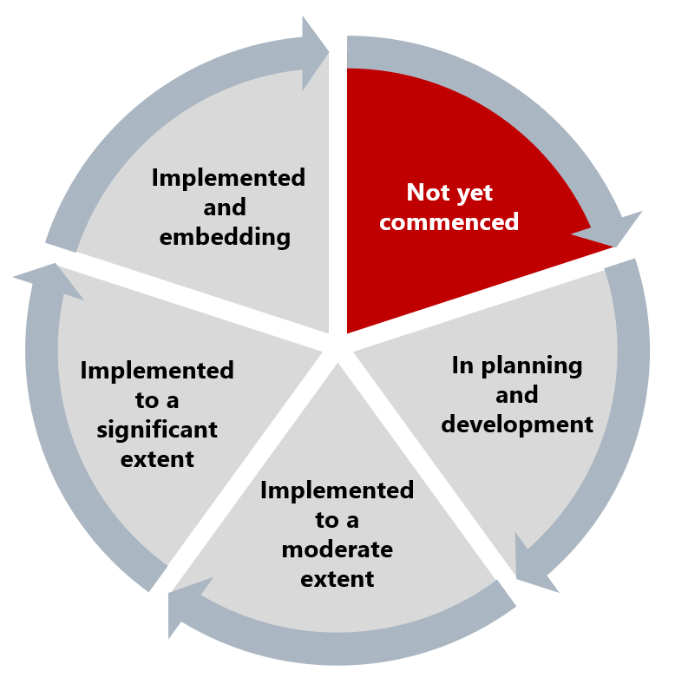

The Commission has assessed implementation of this recommendation as not yet commenced. The Commission understands this is to begin in 2025.

## What measures are still needed?

As Ambulance Victoria develops its workplace flexibility strategy, it should prioritise training for people managers, new staff and graduates to ensure they are aware of their rights and obligations under the *Equal Opportunity Act 2010* (Vic). KPIs for managers to formally incentivise and acknowledge inclusive leadership behaviour will ensure accountability and demonstrate the organisation’s commitment to workplace flexibility.

Consistent with Recommendation 28: Removing structural barries to career advancement and Recommendation 31: Implementing and tailoring the Think Flex First Framework, work to improve flexibility is a key enabler to improving career opportunities for people with protected characteristics requiring flexibility, including women and people with disability. See Reform Barrier: Flexibility and Reform Barrier: Archetypes – Diversity and Inclusion.