# Recommendation 37: Embedding sustained learning and development

Recommendation 37 requires Ambulance Victoria to support managers to develop and demonstrate improved people-management capabilities and inclusive leadership. It builds on Recommendation 36: Strengthening workplace equality education and training and requires managers to have performance development plans (PDPs) by December 2022 with standardised KPIs for workplace equality and people management.

Recommendation 37 also focuses on the capability of managers to lead with a workplace equality mindset through tools such as 360 feedback, secondments and cross-sector communities of practice. It further requires updating of the existing Leading Together program for rollout to all managers and acting managers, and for acting managers to have a mentor. The Leading Together programitself should be regularly evaluated to assess impact and embed improvement.

## Recommendation intent and why it matters

Embedded and sustained learning and development for leaders and managers will help ensure people are treated fairly, with respect and dignity by their leaders and managers. They will also help to improve effective delivery of emergency health care by allowing employees and first responders to be the best they can be.

Leadership is at the core of change management, especially when reforming workplace culture. A focus on supporting managers at Ambulance Victoria will:

* improve leadership and management capabilities, particularly for new and acting managers
* build inclusive styles of leadership to drive safety and respect
* build psychological safety for employees
* support leaders and managers to apply leadership and management skills in everyday practice and undertake continuous learning
* improve the ability of leaders and managers to comply with the *Equal Opportunity Act 2010* (Vic).

## Findings

### What we found in Phase 1 of the Review

In Phase 1 of the Review,[1] the Commission found the Leading Together program at Ambulance Victoria needed updating to better reflect workplace equality, safety and respect. Leading Together content did not link with PDPs or standardised KPIs. Performance appraisals were inconsistent and there were missed opportunities to provide feedback. See Figure 12F of the Phase 1 Report.

The Leading Together programwas not available to acting managers (of whom there were significant numbers) and there was no way of ensuring acting managers were monitored and supported while they were in acting roles.

### What we found in Phase 3 of the Review

**Ambulance Victoria updated and relaunched the Leading Together program in October 2023**

FranklinCovey (an external delivery partner) collaborated with a working group of over 40 operational and non-operational staff to conduct a training needs analysis to identify key capability requirements to inform the Leading Together program. The identified capabilities were aligned with leadership content from the FranklinCovey suite such as ‘7 habits of highly effective people’.

The Commission found that this updated program was piloted from November 2022 to July 2023, initially offering access to all incumbent and acting frontline leaders. In January 2024, the program was expanded to include all leaders and aspiring leaders.

Ambulance Victoria told that Commission that between its launch in October 2023 and April 2024, 425 employees, comprising incumbent leaders, acting leaders and individual contributors, participated in Workshop 1 and are progressively attending Workshops 2, 3 and 4, representing 150 different position titles.

**The Leading Together program has received positive feedback**

During the Progress Evaluation Audit, Ambulance Victoria told the Commission that it had evaluated participant feedback from the Leading Together program and reported:

* Participants are actively engaging and acquiring practical tools to enhance their personal and leadership effectiveness.
* Participants reported increased confidence in leading, contributing to cultural change and aligning their leadership with organisational values while adopting a growth mindset.
* Participants felt the program provided a safe learning environment that promotes confidence and knowledge through shared experiences.
* There is a need for greater participation to build momentum and shared accountability in driving change.

In the workforce survey, views of the program were generally positive. Of the 273 survey participants who said they had participated in the Leading Together program:

* 62% agreed that what they had learnt would help them be more inclusive in their leadership
* 59% agreed that what they had learnt would help them be more effective in resolving conflict
* 75% agreed that a role as a leader in promoting equality is as important as a role in promoting clinical excellence.

**Ambulance Victoria has not met the deadline of December 2022 to ensure managers have PDPs with standardised KPIs for workplace equality and people management in place**

Ambulance Victoria has reported that it has taken time to review and refine the Leading Together program and therefore postponed the development of the new PDPs to 2024.

Unfortunately, this delays the accountability component of the Learning Together program where managers need to apply their learning as it is monitored through standardised KPIs. This is a key component of any behaviour-change process. This was also identified in discussions with the workforce during the Progress Evaluation Audit.

The other is around our capability uplift. So, in terms of leadership capability, we rolled out our Leading Together program and a few other things, but we haven't really looked at unpacking what's the actual requirement of whether you want to be a team manager or senior team manager, duty manager or CSO [Clinical Support Officer] … How we actually build the transaction and leadership capability of our staff to feel confident and competent in doing what they need to do to lead people. That needs a fair bit of work.

Participant

### Progress in achieving change

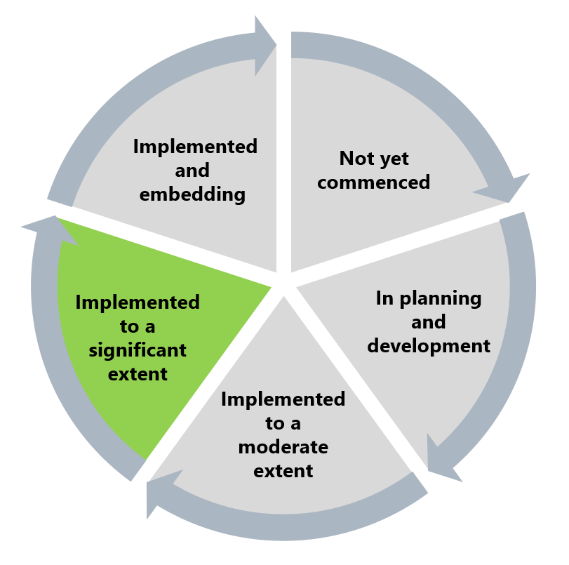.

The Commission has assessed this recommendation as implemented to a significant extent. There has been significant work done to improve the Leading Together program to include blended learning over a 12-month period. The program is receiving positive feedback and is valued among managers.

The delay in setting up PDPs with standardised KPIs for workplace equality and people management means that learnings are not yet being applied consistently. This limits the effect of the Leading Together program to change attitudes and behaviours towards workplace equality in Ambulance Victoria.

## What measures are still needed?

Full implementation of this recommendation requires the setting of KPIs linked to the Leading Together program to be built into PDPs. Those in acting manager roles should also be given the opportunity to participate in the Leading Together program and be assigned mentors to support their leadership practice.

To embed this recommendation into regular practice, Ambulance Victoria should continually improve the Leading Together program by committing to further entrenching current workplace equality content into the program. See Reform Barrier: Archetypes – Diversity and Inclusion.

Implementation of this recommendation will advance efforts to promote Reform Enabler: Culture of Prevention and Reform Enabler: Distributed Leadership.

1. Victorian Equal Opportunity and Human Rights Commission, Independent Review into Workplace Equality in Ambulance Victoria: Phase 1 (Volume II, 2022) 710.