# Recommendation 36: Strengthening workplace equality education and training

Recommendation 36 requires Ambulance Victoria to upskill its whole workforce in their recognition and understanding of workplace equality. This involves engaging an external training provider with approaches to workplace equality and leadership development to develop this training and embed it into induction and annual training programs. Training should be tailored to role needs, especially for managers. In addition to the training, Ambulance Victoria should develop practical tools and resources to support the workforce, and leaders and managers, to apply key learnings and develop a mechanism for tracking and monitoring training completion rates.

The recommendation required the workplace equality training to be rolled out sequentially, with the management training program delivered by December 2022, followed by training for all employees and first responders by July 2023.

## Recommendation intent and why it matters

Strengthened workplace equality education and training are necessary to effectively advance workplace equality. This will help create safe workplaces, by eliminating or reducing the risk of harm and stopping workplace harm before it occurs.

It is crucial for all leaders and staff to engage in continuous and regular education and development. This will improve understanding of Ambulance Victoria’s vision of an inclusive, respectful and equitable workplace. Strengthening workplace equality capabilities among leaders and managers will also support their confidence to identify and respond to unlawful behaviour and appropriately deal with incivility.

Education and training programs should be regularly monitored to measure their impact and ensure they reflect best practices.

## Findings

### What we found in Phase 1 of the Review

In Phase 1 of the Review,[1] the Commission found that many of Ambulance Victoria’s approaches to meeting its *Equal Opportunity Act* *2010* (Vic) obligations were not compliant or were in progress. See section 12.5.1 of the Phase 1 Report.

Among leadership and management there was not consistent knowledge or awareness of the *Equal Opportunity Act* *2010* (Vic). Leaders and managers also lacked skills to prevent harm, call out unlawful conduct and follow necessary processes, including responding to complaints. The Commission also found a lack of structures for enforcing behavioural expectations and accountability for conduct. Ambulance Victoria’s previous workplace equality training was assessed as narrow in scope and did not reflect leading practice.

### What we found in Phase 3 of the Review

**Ambulance Victoria engaged a consultant to create two workplace equality eLearning modules**

The Commission found that two modules were developed by external agency Safetrac and released in early 2024.

*Module 1: Anti-Bullying and Anti-Harassment* is designed for all employees and volunteers. This module contains topics related to:

* unlawful harassment
* sexual harassment
* vilification
* bullying (including upwards forms, cyberbullying and what does not constitute bullying).

*Module 2: Responding to Both Harassment and Bullying and Equal Employment Opportunity* is designed for managers. Module 2 contains topics related to:

* the law
* employers’ obligations and responsibilities
* breaches of anti-discrimination laws
* reasonable adjustments and flexible working arrangements
* reasonable precautions and discrimination, complaint handling and workplace culture.

**The eLearning modules have had good uptake and received positive feedback**

The Commission found that the eLearning modules are a good introduction to workplace equality, provide content that is relevant and engaging, and can be accessed flexibly. The Commission found that uptake among the workforce has been good, with a greater number of operational staff having completed the modules than non-operational staff, and completion rates being similar across metropolitan and regional areas.

The *Anti-Bullying and Anti-Harassment* eLearning module was launched first in January 2024 to all employees and volunteers. As of 1 June 2024 there have been:

* 9,194 enrolments
* 4,029 (44%) completions.

The *Responding to Both Harassment and Bullying and Equal Employment Opportunity* eLearning module for managers was released to all leaders in February 2024. As of 1 June 2024 there have been:

* 1,002 enrolments
* 291 (29%) completions.

Ambulance Victoria has indicated that the lower completion rate is due to new enrolments because of leadership secondments, rotations and new appointments. The module has been completed by slightly more operational than non-operational leaders.

Of participants in the Commission’s Progress Evaluation Audit 2024 workforce survey who had completed the *Anti-Bullying and Anti-Harassment* eLearning module and responded to the questions:

* 58.2% agreed that their understanding of their role in preventing bullying/harassment had improved
* 50.1% agreed that their understanding of Ambulance Victoria’s positive role had improved
* 70.2% were confident they could apply what they had learnt.

**Ambulance Victoria plans to roll out face-to-face training as part of the Upstander program, to follow on from the eLearning modules**

The Commission understands that Ambulance Victoria chose to roll out eLearning courses in the first instance prior to face-to-face training to ensure the program was delivered in a timely and accessible way. The Commission has been advised that face-to-face training will complement the eLearning in the face-to-face Upstander program.

Ambulance Victoria also approached the Commission to discuss the development of a workplace equality program. The organisation expressed interest in *Managing and leading best practice for equal opportunity in the workplace* – the managers’ program provided by the Commission’s Education team.

### Progress in achieving change

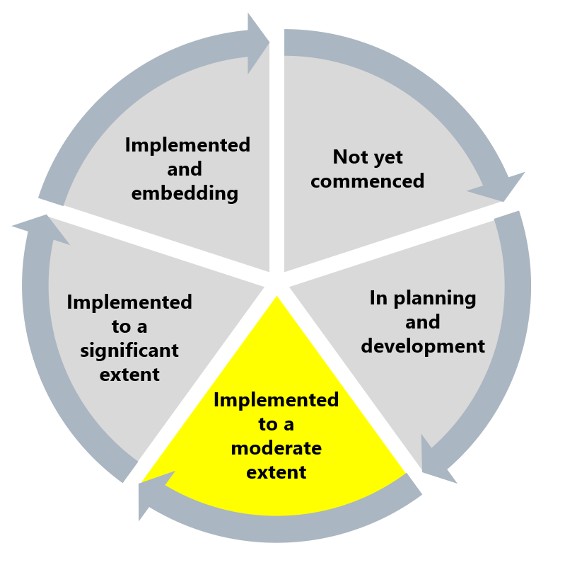

The Commission has found Ambulance Victoria has implemented this recommendation to a moderate extent. While there are digital training modules now in place, they were not developed and rolled out within the original timeframe and were not accompanied by incentives for completion or completion-rate targets. This has contributed to a lack of understanding among managers about how to identify and respond to unlawful behaviour and a lack of confidence to identify and appropriately deal with incivility.

## What measures are still needed?

It is important that Ambulance Victoria remains focused on continuous learning, ensuring the workforce has completed the eLearning modules at a minimum. Real behaviour change comes with opportunities to learn, apply and be held accountable. Ambulance Victoria should continue to find other opportunities to:

* embed workplace equality learning in other learning throughout the organisation (such as the Leading Together program and Mobile Intensive Care Ambulance training)
* reinforce learning in the day-to-day work of the organisation
* include information on different *Equal Opportunity Act 2010* (Vic) protected attributes in training materials (see Reform Barrier: Archetypes – Diversity and Inclusion).

Ambulance Victoria must develop the practical tools and resources for managers to apply key learnings from these programs – tailoring these to the needs of managers as their skills grow. The monitoring and evaluation of the programs should inform improvements in the training, ensuring it responds to the needs of learners.

Work to promote the Reform Enabler: Culture of Prevention would be beneficial in addressing legacy structural and enforcement issues regarding behavioural expectations and accountability for workplace equality.

1. Victorian Equal Opportunity and Human Rights Commission, Independent Review into Workplace Equality in Ambulance Victoria: Phase 1 (Volume II, 2022) 707.