# Recommendation 40: Updating and strengthening governance documents

Recommendation 40 requires Ambulance Victoria to review and update key governance documents to include a strong statement of commitment to and shared responsibility for workplace equality and safety that underpins other corporate priorities.

## Recommendation intent and why it matters

Strengthening Ambulance Victoria’s governance documents will more consistently and clearly communicate Ambulance Victoria’s commitment to workplace safety. It will also drive organisational system change to meet and maintain *Equal Opportunity Act 2010* (Vic) compliance and to implement measures to improve workplace equality.

## Findings

### What we found in Phase 1 of the Review

In Phase 1 of the Review,[1] the Commission found that while Ambulance Victoria had sound, modern governance systems, it needed to fully harness them to comprehensively address the workplace harms and inequalities identified by the Commission and to drive continual improvement. See section 13.4.1 of the Phase 1 Report.

The accountability for embedding and improving workplace equality is organisational and shared by every part of Ambulance Victoria, with a clear oversight role for the Board.

The Commission found that corporate documentation should more consistently and clearly communicate Ambulance Victoria’s commitment to workplace safety and equality using language that aligns with and reinforces the new values developed under Recommendation 7: Resetting and embedding organisational values.

The Commission recommended that this work be guided by models of minimum and mature policy and process enhancements to drive organisational system change for workplace safety and equality.

### What we found in Phase 3 of the Review

**Ambulance Victoria has updated and strengthened Board and Board committee governance documents to reflect its commitment to workplace equality and safety**

The Commission found that Ambulance Victoria has updated the Board’s key governance policy documents, including covering pages for Board by-laws and the Audit and Risk Committee terms of reference, to include its fair, safe and inclusive commitment:

*‘The Board is committed to role modelling and overseeing the realisation of a safe, fair and inclusive workplace where everyone is respected and valued. This commitment includes ensuring that our organisation takes appropriate, timely action to provide culturally sensitive and inclusive care to Aboriginal and Torres Strait Islander peoples and delivers on our commitment to reconciliation.’*

**Ambulance Victoria has updated and strengthened core corporate frameworks and policies in line with its commitment to workplace equality and safety**

The Commission found that Ambulance Victoria’s core corporate frameworks and policies include statements of commitment to a fair, safe and inclusive Ambulance Victoria. This is evident in the [Your AV Roadmap 2022–27](https://www.ambulance.vic.gov.au/your-av/your-av-roadmap/) in which Ambulance Victoria commits to working towards its vision of a safe, fair and inclusive workplace and also in the Your AV Roadmap – Outcomes Focussed Model.

**Ambulance Victoria’s Strategic Plan and annual reports reflect its commitment to workplace equality and safety**

During the Progress Evaluation Audit, the Commission found that in reference to its People Pillar, Ambulance Victoria’s strategic plan 2023–2028 includes the following statements:

*‘Underpinning our People Pillar is our commitment to creating a safe, fair and inclusive workplace, where our people thrive because they feel engaged, valued and well – and with our commitment to inclusion and diversity, our people are as diverse as the community we support.’*

*‘We commit to creating a safer place for our people to work and volunteer, and a more progressive and capable workplace where our people thrive.’*

The Commission also found that Ambulance Victoria’s 2022–23 Annual Report Strategic Plan Summary includes an outcome on Ambulance Victoria being a great place to work and volunteer, and outlines clear objectives to meet that outcome in line with the organisational commitment to a fair, safe and inclusive Ambulance Victoria.

### Progress in achieving change

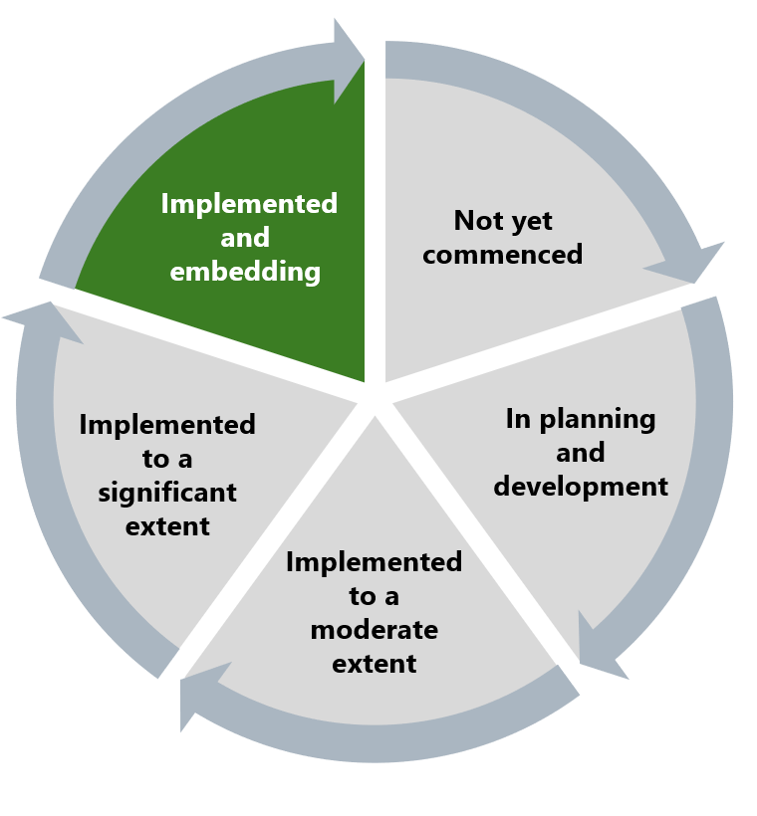

The Commission has assessed that Ambulance Victoria is implementing and embedding this recommendation through updated and strengthened governance documents that clearly include its safe, fair and inclusive commitment. This commitment will underpin other corporate priorities and help drive workplace equality reforms.

## What measures are still needed?

Board oversight of workplace equality and safety initiatives is crucial in promoting a shared responsibility for reform. Holding leadership accountable ensures that reform initiatives receive the necessary attention and resources, and fosters a culture where every level of the organisation feels responsible for upholding these principles. Board oversight will help to reduce levels of discrimination, racism, exclusion and other negative behaviours identified in Phase 1 of the Review. See Reform Barrier: Archetypes – Diversity and Inclusion.

The Commission encourages Ambulance Victoria to continue entrenching the organisation’s commitment to workplace safety and equality in organisational reports, policies and frameworks. By embedding its values deeply into the fabric of the organisation, Ambulance Victoria can ensure a sustained focus on promoting workplace equality and safety.

Sharing this information with the broader workforce is essential to promoting the Reform Enablers of Enhancing Communication and Workforce Commitment. By effectively communicating strong statements of commitment to and shared responsibility for workplace equality and safety, Ambulance Victoria’s Board can build trust and demonstrate its commitment to positive change. This approach ultimately motivates staff and reinforces the organisation’s dedication to a fairer, safer and more inclusive Ambulance Victoria.

1. Victorian Equal Opportunity and Human Rights Commission, Independent Review into Workplace Equality in Ambulance Victoria: Phase 1 (Volume II, 2022) 745.