# Recommendation 41: Board learning through reflective practice

Recommendation 41 requires the Ambulance Victoria Board to understand the drivers of discrimination, sexual harassment, bullying and victimisation identified in the Commission’s Phase 1 Report. Through a reflective facilitated workshop, the Board should review and discuss how these drivers have shaped the Board’s oversight of workplace equality and the workforce’s experiences of workplace equality, how the drivers may influence reform implementation and how they may affect other interdependent aspects of organisational performance.

In June 2022 during Phase 2 of the Review, Ambulance Victoria sought advice from the Commission on a proposed approach to engaging in reflective practice specifically at the Board level. The approach proposed included key deliverables of the core process, a method for a cyclical ‘deep dive’ review of the process and the development of a framework. The Commission’s response to this request for advice was positive and specified that the approach aligned with the intent of the Commission’s recommendation.

## Recommendation intent and why it matters

The positive duty[1] under the *Equal Opportunity Act* *2010* (Vic) requires reasonable and proportionate measures to eliminate unlawful discrimination and sexual harassment as far as possible. See section 3.2.1 of the Phase 1 Report.

Reflective practices will ensure that Ambulance Victoria has a clear understanding of the current barriers to positive duty compliance and enable the organisation to develop effective measures to eliminate unlawful conduct as far as possible. It is reasonable and proportionate for an organisation of Ambulance Victoria’s size to ensure that these measures are informed and effective.

Recommendation 41, along with Recommendation 1: Learning through reflective practice and Recommendation 42: Organisational healing and cultural change through reflective practice, seeks to embed reflective practice as a tool for listening into the workplace reform programs.

## Findings

### What we found in Phase 1 of the Review

In Phase 1 of the Review,[2] the Commission found preventive measures towards workplace safety and equality were limited by the organisation-wide lack of understanding of the drivers of discrimination, sexual harassment, bullying and victimisation. See section 13.4.2 of the Phase 1 Report.

Recommendation 41 recognises the importance of reflecting on cultural drivers that have shaped workforce inequality at Ambulance Victoria rather than only focusing on solutions.

### What we found in Phase 3 of the Review

**The Ambulance Victoria Board engaged in reflective facilitated workshops to review and discuss drivers of discrimination, sexual harassment, bullying and victimisation**

The Commission found that 4 reflective practice sessions were conducted with the Board during 2023, run by Andrew Hollo from Workwell Consulting. Workshop documentation indicates the Board engaged in discussions about the drivers of discrimination, sexual harassment, bullying and victimisation identified in the Commission’s Phase 1 Report, including how the drivers have shaped workforce equality experiences at Ambulance Victoria.

Ambulance Victoria’s Board told the Commission it had participated in reflective practice workshops and in the development of the reflective practice framework. This framework has been shared with the Executive and will be shared with managers. Outcomes from this workshop influenced the development of the values and Safe Fair Inclusive Your AV Roadmap 2022–2027.

**Ambulance Victoria’s workforce lacks confidence in senior leadership to make changes to improve workplace safety and equality**

Throughout the Progress Evaluation Audit, the Commission heard from many parts of Ambulance Victoria’s leadership that the organisation has been establishing the foundation for change and therefore most of the work done so far to improve workplace safety and equality may not be visible to the workforce. This approach has resulted in a lack of workforce trust that the reforms will be implemented.

Workforce survey results show:

* 11% of respondents agreed that senior leaders are taking action to reduce unlawful/harmful conduct.
* 11% of respondents trusted that Ambulance Victoria will implement all recommendations.
* 59% of respondents said that they have seen either no change or negative change since July 2022.

This is an indication that either outcomes from the Board’s reflective practice are not being communicated to the workforce or the Board’s reflective practice is failing to identify the drivers of discrimination, sexual harassment, bullying and victimisation.

### Progress in achieving change

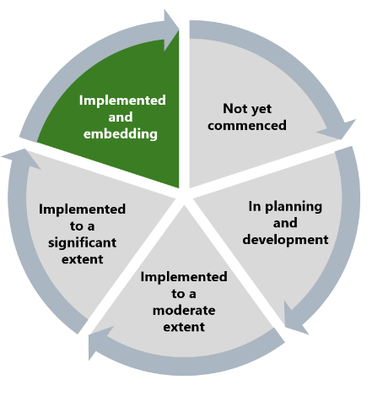

The Commission found this recommendation to be implemented as the activities required by the recommendation have been delivered.

## What measures are still needed?

The Board’s ongoing reflective practice, which thoroughly examines the drivers of discrimination, sexual harassment, bullying and victimisation at Ambulance Victoria, is instrumental in Enhancing Workforce Commitment. By fostering accountability and a commitment to a safe and inclusive workplace, these efforts help to ensure that all employees feel valued and empowered to contribute fully to the reforms.

This recommendation should be embedded by ensuring the Board’s reflective practice continues to consider the drivers of discrimination, sexual harassment, bullying and victimisation at Ambulance Victoria. Experiences of these behaviours are ongoing and should be addressed as a priority as part of the Reform Barrier: Archetypes – Diversity and Inclusion.

Board reflective practice should consider how these drivers of unlawful behaviour influence reform implementation, continuous improvement and other interdependent aspects of organisational performance. See Reform Barrier: Change Management.

Clearly communicating to the workforce on the outcomes of the Board’s reflective practices will also help to build workforce trust in the Board’s commitment to reforms. See Reform Enabler: Enhancing Communication.

1. Victorian Equal Opportunity and Human Rights Commission, Independent Review into Workplace Equality in Ambulance Victoria: Phase 1 (Volume I, 2021) 132.
2. Victorian Equal Opportunity and Human Rights Commission, Independent Review into Workplace Equality in Ambulance Victoria: Phase 1 (Volume II, 2022) 748.