# Recommendation 42: Organisational healing and cultural change through reflective practice

Recommendation 42, along with Recommendations 1: Learning through reflective practice and Recommendation 41: Board learning through reflective practice, seeks to embed reflective practice as a tool for listening into the workplace reform programs.

Recommendation 42 requires Ambulance Victoria to embed a reflective practice program into the new prevention plan required by Recommendation 3: A holistic evidence-based prevention plan.

This reflective practice program should be informed by research and models of organisational healing and cultural change, and confirm the Board’s and the CEO’s commitment to change that addresses the Review findings and recommendations.

## Recommendation intent and why it matters

Organisational healing and culture change take time and sustained effort. Under the *Equal Opportunity Act 2010* (Vic), the positive duty[1] aims to address systemic causes of discrimination, sexual harassment and victimisation. See section 3.2.1 of the Phase 1 Report.

Reflective practices play a critical role in both prevention and response, encompassing key standards such as knowledge, organisational culture and response mechanisms. By employing reflective practices, Ambulance Victoria can clearly identify the barriers to compliance and develop effective strategies to eliminate unlawful conduct.

Implementing an ongoing reflective practice strategy will help Ambulance Victoria better understand current barriers to compliance with the positive duty, thereby enhancing trust in the leadership team and fostering a culture of safety and respect.

## Findings

### What we found in Phase 1 of the Review

In the Phase 1 Report,[2] the Commission identified the need to rebuild trust in leadership across Ambulance Victoria to enable workplace safety and equality, and the importance of listening to the workforce as a tool to enable this rebuilding. See section 13.4.2 of the Phase 1 Report.

In December 2022, in response to the proposal for Phase 3 of the Review, Ambulance Victoria wrote to the Commission about its intention to action this recommendation through activities designed to embed reflective practice across the organisation, rather than by limiting the scope of this work to the prevention plan.

### What we found in Phase 3 of the Review

**Ambulance Victoria’s senior leaders and other staff participated in reflective practice workshops in 2021 and 2022**

The Commission found that in November 2021 Ambulance Victoria’s Executive Committee and senior leadership team participated in reflective practice sessions facilitated by ZALT Group. These workshops were case study based and focused on enabling leaders to listen and connect with the experiences of Ambulance Victoria’s workforce.

Further, in April 2022 reflective sessions for staff, facilitated by the Executive or their departmental leads, gave workforce members an opportunity to express their own experiences at Ambulance Victoria. The Equality and Workplace Reform division was formed so that the workforce can provide feedback on leadership decisions.

In May 2023 the Board of Ambulance Victoria engaged in reflective practice sessions (see Recommendation 41: Board learning through reflective practice) and a reflective practice framework was developed; a reflective practice session was held with the Ambulance Victoria’s senior leadership team, supported by this framework, in March 2024.

The Commission considers that Ambulance Victoria’s Safe Fair Inclusive, Your AV Roadmap 2022–2027 demonstrates a commitment to reflective practice. It outlines plans to continue using the reflective framework at a Board and Executive level and for the framework to be delivered across the organisation from 2025.

**Steps taken towards organisational healing and culture change are not being felt by the wider Ambulance Victoria workforce**

During Progress Evaluation Audit research, senior managers from Ambulance Victoria’s corporate teams acknowledged that much of the organisational healing and culture change work undertaken to date has been foundational and is not yet ‘seen’ by the broader workforce and among operational staff particularly.

I think we need to go back to them and relaunch them or do more work on them at an operational level, coalface level, to embed them. Yeah, there's a lot of terminology around, you know, living the values and showing the values and reflecting on the values. But I think to the two people in blue shirts in the white truck driving down the road, that that's not something they would reflect on on a daily basis. So, I think we've lost that from our operational level and we need to get that back.

Participant

Responses to the Commission’s Phase 3 workforce survey demonstrated that employees do not feel listened to and do not feel that Ambulance Victoria is committed to or understands how to make meaningful change. Only 14% of respondents agreed that Ambulance Victoria listens to the views of employees about workplace changes to reduce/prevent unlawful/harmful conduct. Only 27% of survey respondents agreed that Ambulance Victoria is committed to making its workplace free from unlawful and harmful conduct.

More generally, there is very little agreement that things have improved and trust in leadership is very low.

### Progress in achieving change

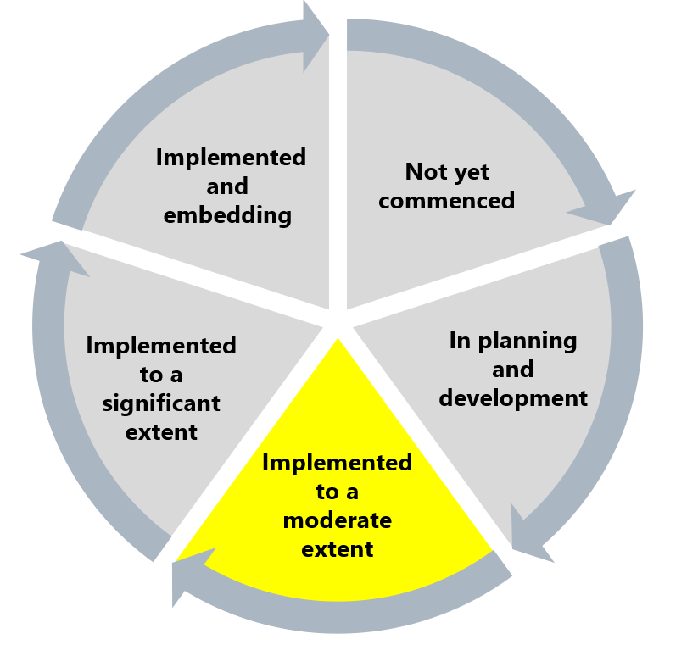

The Commission assessed this recommendation as implemented to a moderate extent. While the commitment to reflective practice among organisational leaders appears high, the work done by leadership towards the implementation of this recommendation is invisible to the workforce, which is limiting the impact and rebuilding of trust in leadership.

## What measures are still needed?

The Commission considers that the clear desire for organisational healing is being hampered by Ambulance Victoria’s approach to communicating to the workforce about reform progress (see Reform Enabler: Enhancing Communication). Ambulance Victoria should ensure the listening process, in reflecting on workplace equality, is person-centred and trauma-informed, aware of power imbalances and seeks to create safe spaces and practices for reflection and discussion.

By embedding reflective practice on workplace equality into the leadership approach, Ambulance Victoria can promote a culture of prevention where mistakes are acknowledged and harm is addressed at a local level without requiring unnecessary escalation or risking further harm. This proactive approach ensures that issues are managed efficiently and constructively, fostering a more accountable workforce. It empowers leaders and staff to learn from missteps and continuously improve, enhancing both physical and psychological safety within the organisation. See Reform Barrier: Culture of Prevention.

Ambulance Victoria’s organisational healing will benefit from acknowledgement of the unique identities of its workforce, alongside strong organisation-wide commitment to the reforms. This recognition helps address the Reform Barrier: Archetypes – Diversity and Inclusion and leverages the Reform Enabler: Workforce Commitment, ensuring that every employee feels valued and engaged. By fostering an inclusive environment and embracing diverse perspectives, Ambulance Victoria can drive continuous improvement and create a supportive, cohesive workforce dedicated to achieving safety and equality.

1. Victorian Equal Opportunity and Human Rights Commission, Independent Review into Workplace Equality in Ambulance Victoria: Phase 1 (Volume I, 2021) 132.
2. Victorian Equal Opportunity and Human Rights Commission, Independent Review into Workplace Equality in Ambulance Victoria: Phase 1 (Volume II, 2022) 749.